

[Company Name]
[The business plan title]
01 | Summary
1.1. | Goals And Objectives
1.2. | Company Description
1.3. | Products/Services
1.4. | Market And Customers
1.5. | Financing Needs
02 | About the Company
2.1. | General Company Information
2.2. | About the Project
2.3. | Swot Analysis
03 | Market Analysis
3.1. | Market Overview
3.2. | Competitive Analysis
3.3. | Consumer Needs
04 | Marketing and Sales
4.1. | Sales Plan
4.2. | Marketing Plan
05 | Business Operations
5.1. | Location And Premises
5.2. | Equipment
5.3. | Technological Process
5.4. | Production
06 | Raising and Allocating Funds
07 | Financial Plan
7.1. | Key Assumptions
7.2. | Profit and Loss Projection
7.3. | Cash Flow Projection
7.4. | Financial Performance
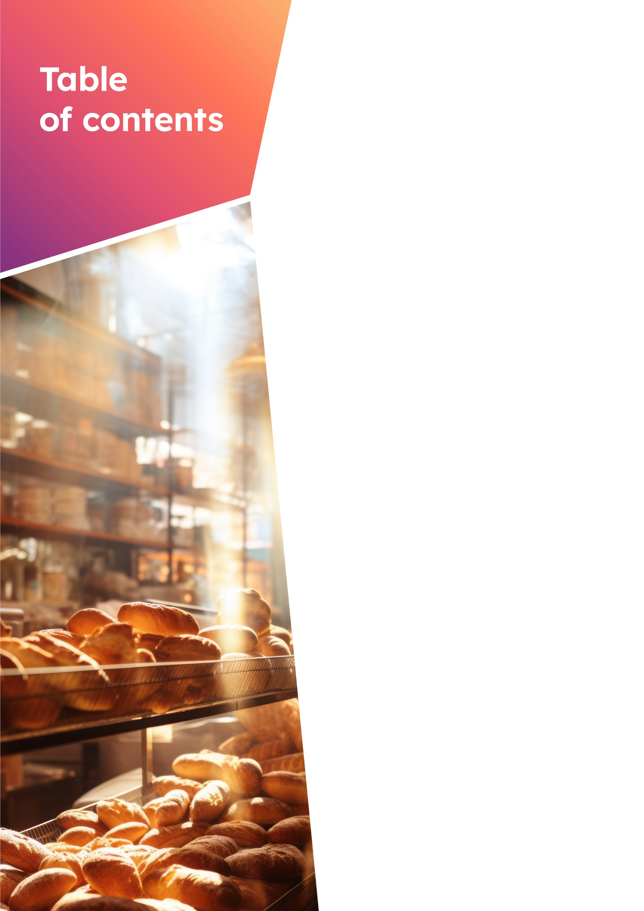
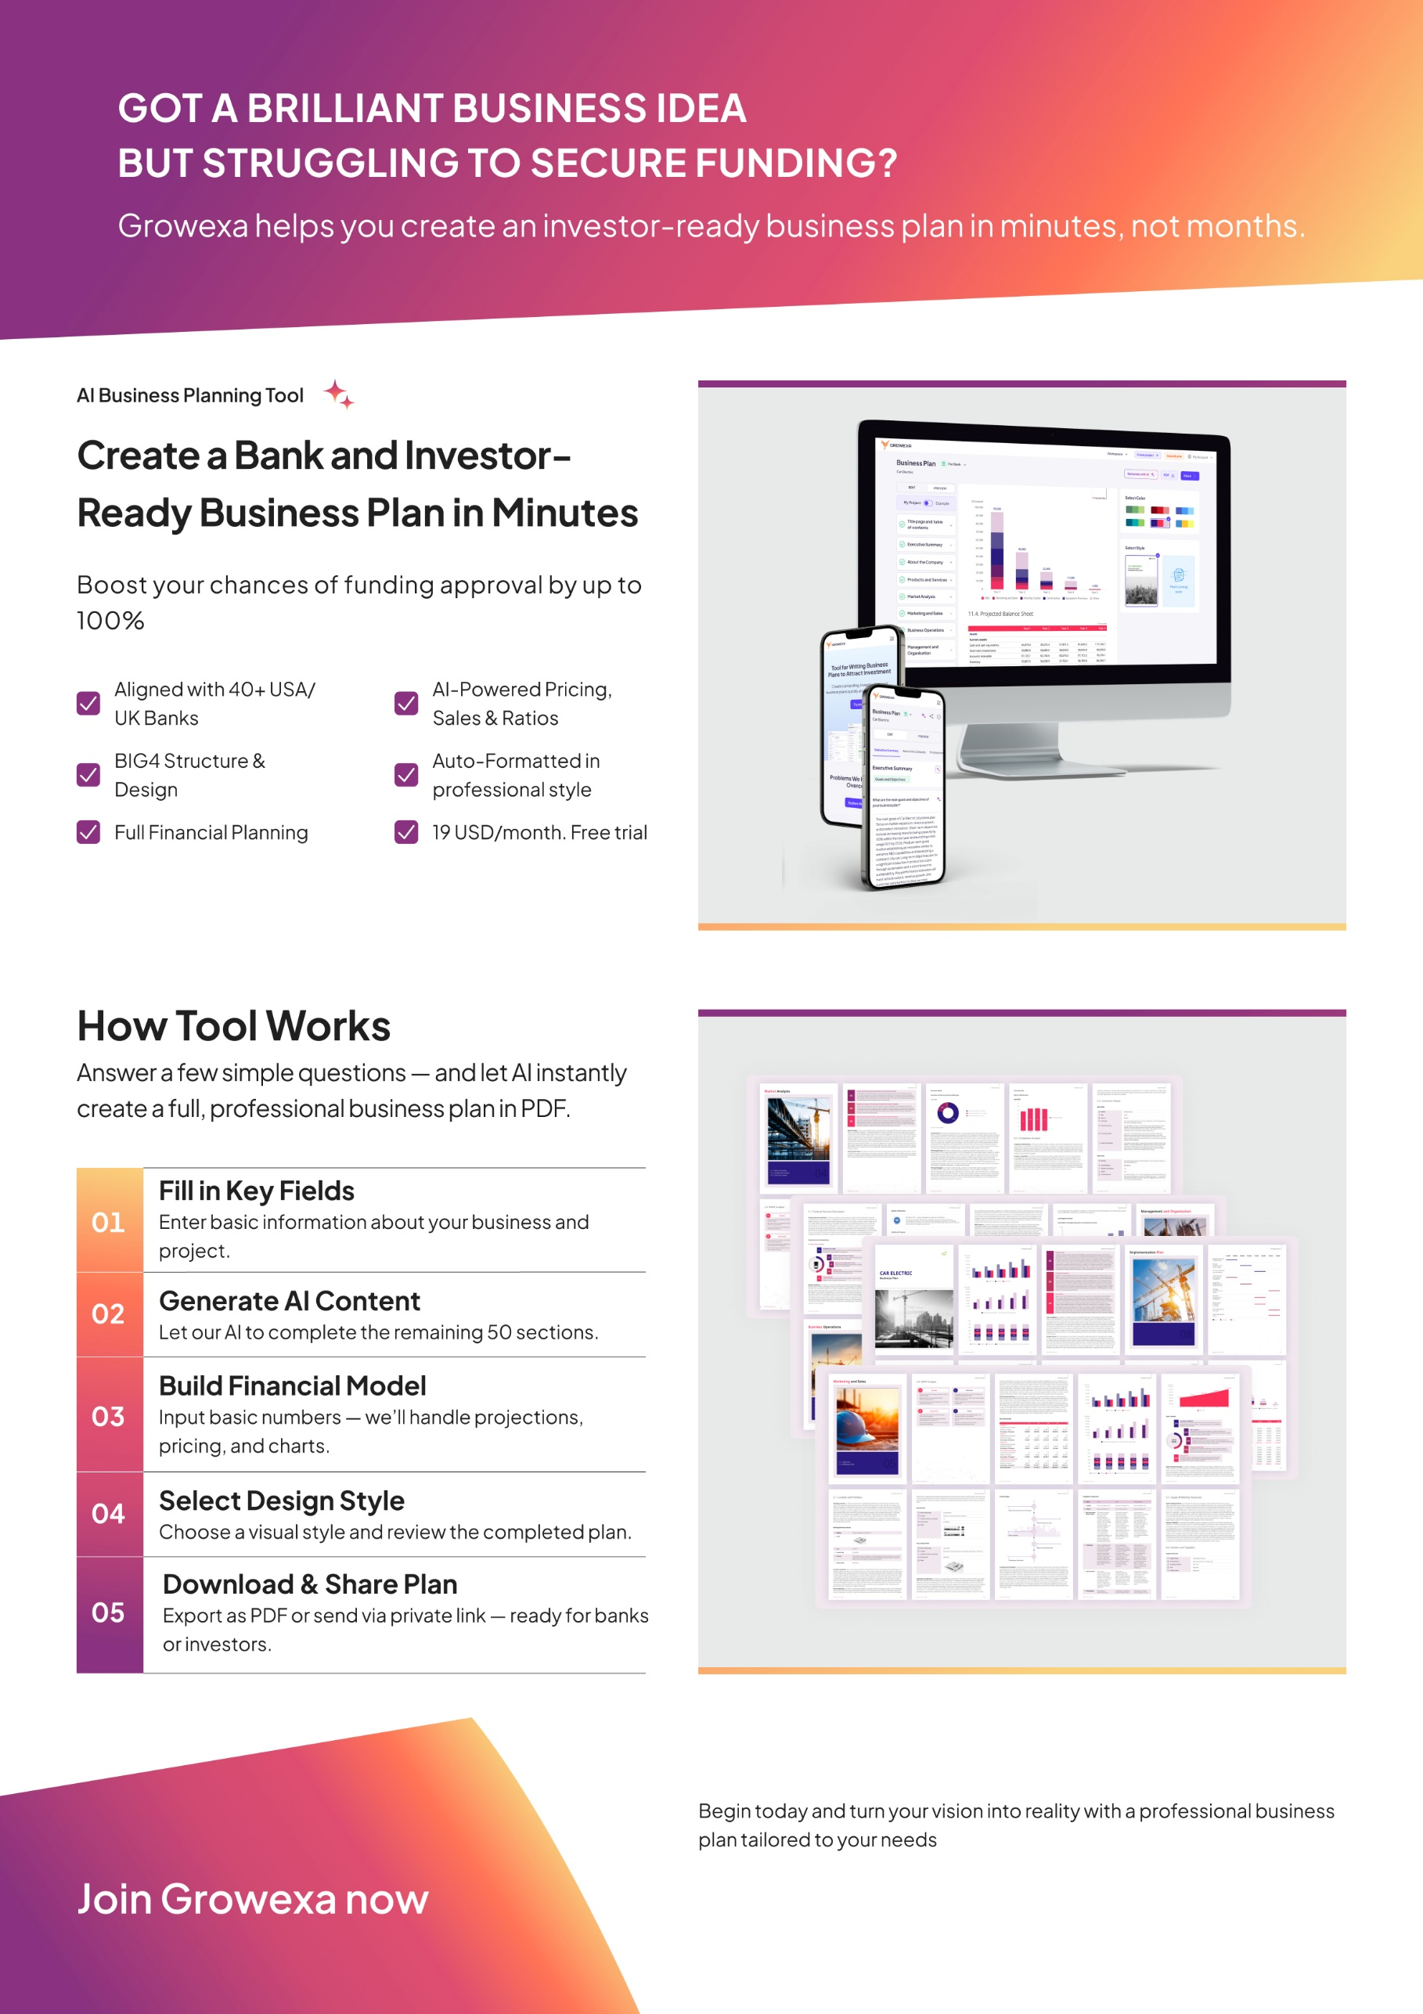
Start your business plan now
Start 3-day free trial
Start 3-day free trial

Template
Contents
  - Goals and Objectives
  - Company Description
  - Products or Services
  - Market and Customers
  - Financing Needs

Summary

Section 1
Section 1 — Summary
- Summary
“
This section offers a concise, comprehensive overview of the business plan, highlighting the project’s key elements and strategic direction. It is critical for providing potential investors, partners, and stakeholders with a clear, high-level understanding of the business and its overall strategic vision. This summary serves as a foundation, outlining the primary goals and roadmap of the business in a way that captures interest and sets the stage for deeper engagement with the rest of the plan.”
  - Goals and Objectives
Main Goals and Objectives
Outline company strategic goals, emphasizing short, medium, long-term objectives aligned with mission and vision. Specify focus areas like market expansion, revenue growth, or product innovation. Discuss strategies, initiatives, KPIs driving goal realization.

Start typing here...

Description of the Project
Succinctly describe investment project essence, be it new facility, modernization, or market expansion. Briefly introduce target business, its industry, market presence, core products, financial health, and strengths, outlining acquisition rationale.

Start typing here...

Strategy for Project Success
Define success strategy pillars: customer focus, innovation, operational excellence. Detail tactics like market differentiation, innovation, efficiency, customer engagement, and adaptation to challenges. Emphasize continuous improvement and adaptability.

Start typing here...

  - Company Description
Company Name
Provide the intended full and official name of your company. If the company is not yet registered, ensure the name reflects your brand vision and planned official registration.

Start typing here...

Registration Date
State the precise date when your company was officially registered, include the year, month, and day of registration.

Start typing here...

Operating Sector
Specify the sector your company operates in, selecting the appropriate level of detail from the provided dropdown options.

Start typing here...

Mission Statement
Define company mission, stating purpose and values. Highlight impact on marketplace or community, emphasizing unique value proposition. Align mission with broader goals, express commitment to principles like innovation, customer service, or sustainability.

Start typing here...

Address of registration
Specify the city and country where your company is officially registered. Provide accurate details to facilitate legal inquiries or business transactions.

Start typing here...

  - Products or Services
Main products/services offered
Introduce your product with an attention-grabbing statement, highlighting its primary purpose and key distinguishing features briefly yet compellingly.

Start typing here...

Product/Service Value and Problem Solved
Clearly state the primary value proposition of your product and its problem-solving capabilities, elaborating on customer benefits and practical impact.

Start typing here...

Product/service development plans
Articulate your organization's strategic vision for product development and expansion, detailing future research initiatives and potential new product categories or sectors.

Start typing here...

  - Market and Customers
Target market and consumption
Provide concise market overview: needs, preferences, pain points addressed. Highlight unique aspects like geographic concentration. Estimate market size citing sources. Emphasize economic value and business opportunities.

Start typing here...

Market Dynamics
Outline market dynamics: forces influencing supply, demand, competition, industry structure. Identify target market CAGR. Discuss current trends: shifts in consumer preferences, tech, best practices. Highlight business impact and adaptability.

Start typing here...

Target Audience
Define target audience: demographics, psychographics, needs. Emphasize product/service fit. Highlight unique characteristics: geography, industry, behavior.

Start typing here...

Sales Channels
Overview primary distribution channels: direct sales, retail, e-commerce. Discuss rationale, considering reach, preferences, industry standards. Address channel-specific advantages and challenges.

Start typing here...

Main competitors
Analyze competitive landscape: main competitors, market share, offerings, reach. Discuss distinctive characteristics or advantages.

Start typing here...

Financing needs
Total Project Cost | $350,000
Conduct a meticulous assessment of the projected expenditures. The comprehensive budgetary analysis should encompass diverse facets such as operational costs, capital expenditures, marketing initiatives, technological investments, and workforce allocations. | $350,000
Funding needs | $245,000
Determine the required funding by conducting a comprehensive assessment of all project expenses and anticipated costs. | $245,000
Funding by own funds | 30%
Specify the percentage of project cost to be financed internally. | 30%
Funding directions | - Research and Development  (R&D) - 8.57%  - Marketing and Sales - 20.00%  - Working Capital - 17.14%  - Construction of Buildings and Facilities - 5.71%  - Purchase of Equipment - 42.86%  - Other - 5.71%
Specify budget allocations for each purpose: R&D, Marketing, Working Capital, Construction, Equipment.

Contents

Section 2 — About the Company
Template
  - General Company Information
  - About the Project
  - SWOT Analysis

About
the Company
Section 2
- About the Company
“
This section offers a detailed company overview, covering its mission, vision, history, and strategic direction. It aims to establish the company's credibility and strategic focus, providing potential investors, partners, and stakeholders with a clear understanding of the business and its growth potential. By outlining the company's foundation and future outlook, this section demonstrates its stability and long-term prospects, reinforcing confidence in its ability to succeed.”
  - General Company Information
Company Brief
Specify a concise company overview. Delve into the distinctive features that set your company apart. Emphasize proprietary technologies, innovative approaches, or unique capabilities contributing to a competitive advantage.

Start typing here...

Name | Whisk & Bloom Bakery
Provide the intended full and official name of your company. If the company is not yet registered, ensure the name reflects your brand vision and planned official registration. | Whisk & Bloom Bakery
Legal Structure | Limited Liability Company
State the legal structure of your company. Options include sole proprietorship, partnership, corporation, or limited liability company (LLC). | Limited Liability Company
Operating industry | Retail Bakeries
Specify the sector your company operates in, selecting the appropriate level of detail from the provided dropdown options. | Retail Bakeries
Address of registration | Austin, Texas, United States
Specify the city and country where your company is officially registered. Provide accurate details to facilitate legal inquiries or business transactions. | Austin, Texas, United States
Registration date | 07.01.2025
State the precise date when your company was officially registered, include the year, month, and day of registration. | 07.01.2025
Website | whisk&bloom.com
Share your company's full web address | whisk&bloom.com
E-mail | info@whisk&bloom.com
Provide the official email address of the company accurately, include the domain name and any relevant department or contact details. | info@whisk&bloom.com
Social networks | facebook.com/Whisk & Bloom Bakery  instagram.com/Whisk & Bloom Bakery  linkedin.com/Whisk & Bloom Bakery  Whisk & Bloom Bakery@mail.com
List the social networks your company uses, along with their respective links. Ensure all links are accurate and lead to your official profiles.

  - About the Project
Description of the Project
Succinctly describe investment project essence, be it new facility, modernization, or market expansion. Briefly introduce target business, its industry, market presence, core products, financial health, and strengths, outlining acquisition rationale.

Start typing here...

Main goals and objectives
Outline company strategic goals, emphasizing short, medium, long-term objectives aligned with mission and vision. Specify focus areas like market expansion, revenue growth, or product innovation. Discuss strategies, initiatives, KPIs driving goal realization.

Goal | Priority | Terms | Mechanism of achievement
Long-term
Establish 5 partnerships with local businesses | Low | May 2026 | Conduct direct sales visits to health-conscious establishments with free samples and wholesale catalog, targeting minimum $500 monthly orders per partner.
Build customer base of 500 repeat customers | Medium | July 2026 | Implement customer loyalty program with personalized offers, host monthly tasting events, and maintain active social media presence to encourage repeat visits.
Short-term
Achieve 15% market share in Austin’s gluten-free bakery segment | High | Dec.  2025 | Establish strong local presence through community partnerships, targeted digital marketing, and participation  in Austin food festivals and farmer’s markets.

Problem Definition
Briefly outline market context and specific problem or need. Articulate industry challenges, emphasizing impact on stakeholders. Identify market gaps creating opportunity for business.

Start typing here...

Contribution to Problem Solving
State business plan subject, highlighting unique solution elements. Outline core features, emphasizing problem-solving approach. Discuss strategic approach, including innovative tech or value propositions. Articulate benefits and outcomes for stakeholders.

Start typing here...

  - SWOT Analysis
Strengths |  | Weaknesses
- Commitment to ingredient transparency and strict allergen controls ensures safety for sensitive customers.  - Specialized production facility dedicated to gluten-free products enhances brand reputation.  - Unique product offerings cater to health-conscious consumers, setting the bakery apart in the market.  - The strong team comprising experienced specialists, and industry professionals. |  | - Limited brand recognition compared to established competitors in the local gluten-free sector.  - Initial startup phase may lead to challenges in securing funding and resources.  - Operational efficiencies may be tested during the early stages of business development.  - Dependence on a relatively small team may lead to resource constraints during periods of high demand.
Identify core competencies and resources giving market edge. Highlight specialized skills, unique capabilities, and brand reputation. |  | Identify company`s internal limitations and challenges. Transparently discuss areas needing improvement: processes, resources, skills. Address gaps in meeting industry benchmarks, operational inefficiencies, and their impact on performance and competitiveness.
Opportunities |  | Threats
- Growing consumer demand for gluten-free products aligns with health trends in the food industry.  - Potential to expand delivery services to reach a larger customer base and enhance convenience.  - Increasing awareness of food allergies creates a market for specialized allergen-friendly products.. |  | - Intense competition from established gluten-free brands like Sweet Ritual and The Gluten-Free Baker.  - Economic downturns may affect consumer spending on specialty food items.  - Regulatory changes could impact food production and labeling requirements.
Analyze market trends and identify opportunities matching company strengths. Discuss consumer shifts, tech advancements, and regulations. Explore leveraging these trends for market expansion, new offerings, or entering untapped segments. |  | Identify and analyze external threats: market trends, competition, economic downturns, regulatory uncertainties. Discuss impact on operations, market share, customer relationships. Articulate potential negative consequences and vulnerabilities.


Contents
Template
  - Market Overview
  - Competitive Analysis
  - Consumer Needs
Market
analysis
Section 3
Section 3 — Market Analysis
- Market Overview
“
This section thoroughly analyses the market environment in which your business operates, encompassing key trends, consumer behaviours, and the competitive landscape. It provides a detailed examination of how your product or service integrates into the current market structure, addressing aspects such as present and future demand, pricing strategies, and competitive positioning. By illuminating these components, this section aids potential investors and stakeholders assess the market potential and strategic opportunities available to your business.”
  - Market Overview
Market Segmentation
Define the market under consideration. Introduce the key characteristics of the market, emphasizing elements that define its nature. Delve into market barriers and challenges that may impact entry or operations. Provide a concise overview of the market segments, emphasizing geographic and industrial categorizations, customer types, etc.

Start typing here...

Product Summary
Describe the primary services or products offered in your target market. What are their key features, main purposes, and pricing strategies? How do these factors influence market demand and competition?

Start typing here...

Consumption Analysis
Describe consumption trends using statistics. Present actual data and forecasted figures, highlighting growth trajectories and market dynamics.

Start typing here...

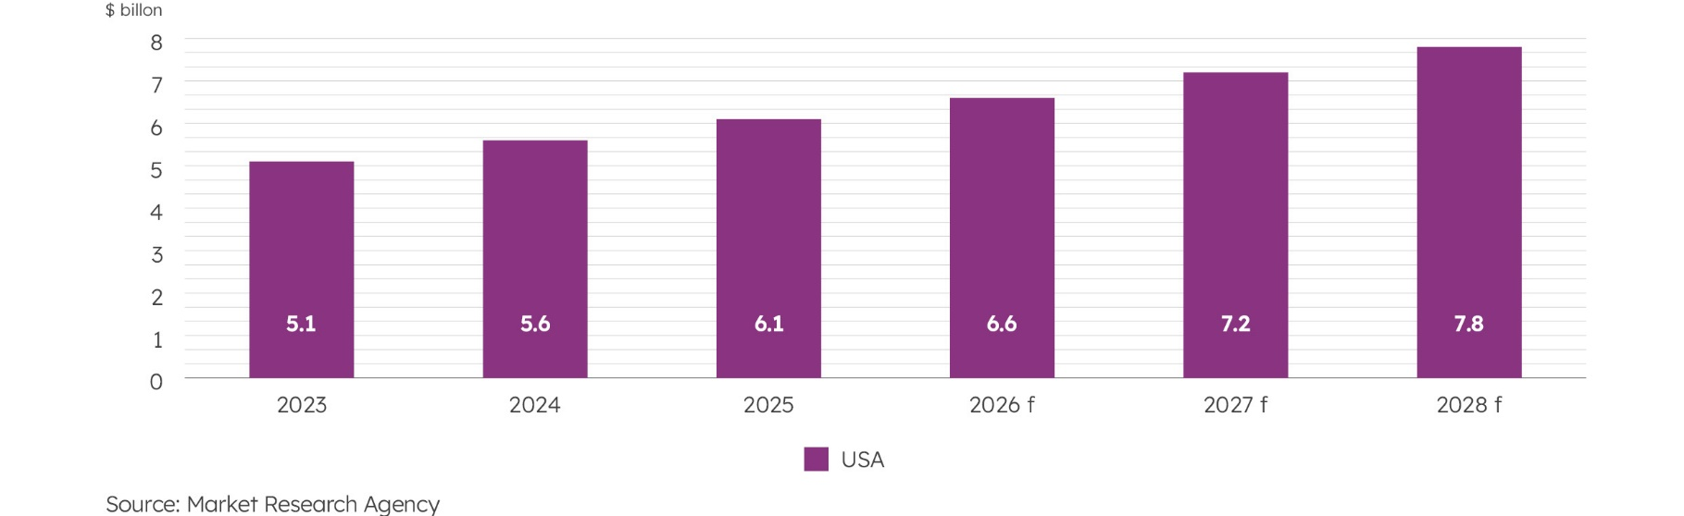
Consumption Forecast
Specify the actual and forecasted consumption in the market (product/service/other market segment/year/unit (volume/currency).
Gluten-free market in the U.S
Sales Strategy
Describe sales channels for the product/service. Detail online platforms, retail partnerships, and direct sales strategies to reach target customers effectively.

Start typing here...

Trend Name
Identify the main market trends. Ensure the trends are relevant to your industry and reflect current market dynamics.

01 | Surge in Allergen-Friendly Product Demand Driven by Health Awareness  Heightened consumer awareness of food allergies and dietary restrictions is leading to a significant increase in demand for gluten-free and allergen-friendly products. This trend is reflected not only in individual purchases but also in the menu offerings of restaurants and cafes, as businesses cater to a growing segment of health-conscious customers who prioritize safe and inclusive food options.
02 | Rapid Growth of E-Commerce and Delivery Services in Bakery Industry  The shift towards online shopping and delivery services has accelerated in the bakery sector, particularly since the pandemic. This trend reflects consumers’ preference for convenience, leading to an increase in online orders for gluten-free products. Bakeries are now leveraging technology to enhance customer experience, streamline operations, and expand their reach beyond local storefronts, catering to a wider audience.
03 | Advancements in Gluten-Free Production Techniques Enhancing Product Quality  Innovative production methods and the introduction of alternative ingredients are significantly improving the taste, texture, and overall quality of gluten-free products. These advancements make gluten-free options more appealing, attracting not only those with dietary restrictions but also mainstream consumers. This trend is vital for maintaining competitive advantage in the growing gluten-free market.

  - Competition Analysis
Competitor Identification
List direct and indirect competitors, explaining their relevance. Highlight similarities in offerings, target markets, and distribution channels, emphasizing competitive advantages and market positioning.

Start typing here...

Competior Comparison
Compare your key competitors (name/logo/location/website/brief description of the product/positioning/sales channels/pricing policy/annual sales volume/market share/customer loyalty level).

Name | Sweet Ritual | The Gluten-Free Baker
Logo | 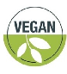 | 
Location | Austin, Texas, United States | Austin, Texas, United States
Website | sweetritual.com | theglutenfreebaker.com
Brief description  of the product | Sweet Ritual specializes in gluten-free desserts including ice creams and cookies, known for inventive flavors and high-quality ingredients. | The Gluten-Free Baker focuses on a variety of gluten-free baked goods, including breads and pastries.
Positioning | Sweet Ritual holds a significant position in the gluten-free market, recognized for its innovative dessert offerings and strong community engagement. | The Gluten-Free Baker has carved out a reputable presence in the gluten-free community, recognized for quality and reliability.
Sales channels | Sweet Ritual operates through their physical storefront, online ordering, and delivery services. | The Gluten-Free Baker primarily sells through their bakery, online orders, and local farmers’ markets.
Pricing policy | Competitive pricing strategy aligning with premium pricing. They also implement seasonal promotions and loyalty discounts. | Value-based pricing strategy combined with competitive rates. They also use promotions and bulk order discounts.
Annual sales volume | $500,000 | $350,000
Market share | 20.00% | 15.00%
Customer Loyalty Level | High | High

  - Consumer Needs
B2C Consumer Profile
Describe the key consumer profile (B2C) (gender/age/income/profession/personal interests/purchasing habits/needs and problems).

Gender | Female
Age | 25-45
Income | $65,000
Profession | Health professionals, educators, and young professionals in tech and wellness industries
Personal interests | Health and wellness, fitness, cooking, outdoor activities, and exploring local food markets. Many are interested in sustainable living and organic products.
Purchasing habits | Frequent buyers of health-conscious products. Prefer shopping at local markets and specialty stores, often influenced by social media and online reviews. Value quality and transparency in ingredients.
Needs and problems | Need for safe, gluten-free products due to allergies or sensitivities. Seek convenience in purchasing options and desire trustworthy brands that prioritize health and ingredient transparency.
Market Satisfaction
Provide an overview of the current customer satisfaction levels within the market. Discuss the overall sentiment of customers toward existing offerings and services. Highlight specific areas where customers express satisfaction and those where improvements are needed. It could include product features, service quality, pricing, or other factors influencing customer perceptions.

Start typing here...

Demand Creation
Analyze whether the business operates in a market where demand is already established or if it is pioneering new demand through innovative products or services.

Start typing here...


Contents
Template
  - Sales Plan
  - Marketing Plan
Marketing
and Sales
Section 4
Section 4 — Marketing and Sales
- Marketing and Sales
“
This section outlines the company's strategic approach to marketing and sales. It details the planned initiatives for marketing, brand positioning, and sales strategies aimed at reaching and engaging the target audience. By describing the advertising campaigns, pricing strategies, sales processes, and tools for customer relationship management, this section illustrates how the company intends to drive revenue growth and establish a competitive position in the market.”
  - Sales Plan
Sales Goals
Outline short-term and long-term sales objectives. Define achievable targets within specific timeframes, considering market trends, competition, and growth projections.

Start typing here...

Sales Plan Details
Provide the sales plan broken down by products/services

 | Y1 | Y2 | Y3 | Y4 | Y5
Gluten-free whole grain bread
In physical, pieces thousand | 19.6 | 23.6 | 28.3 | 34 | 40.7
Selling Price, $/pieces | 6.2 | 6.4 | 6.8 | 7.1 | 7.5
In monetary, $ thousand | 120.7 | 152.1 | 191.6 | 241.2 | 304
Seed-based “power loaf”
In physical, pieces thousand | 12.8. | 14.7 | 17 | 19.5 | 22.4
Selling Price, $/pieces | 6.7 | 7.2 | 7.7 | 8.2 | 8.8
In monetary, $ thousand | 86.1 | 106 | 130.4 | 160.3 | 197.2
Sandwich-style gluten-free white bread
In physical, pieces thousand | 16.8 | 19.7 | 23 | 26.9 | 31.5
Selling Price, $/pieces | 5.7 | 6 | 6.4 | 6.7 | 7.1
In monetary, $ thousand | 95.1 | 117.9 | 146.3 | 181.3 | 224.8
Total, $ thousand | 301.9 | 376.0 | 468.3 | 582.8 | 726.0
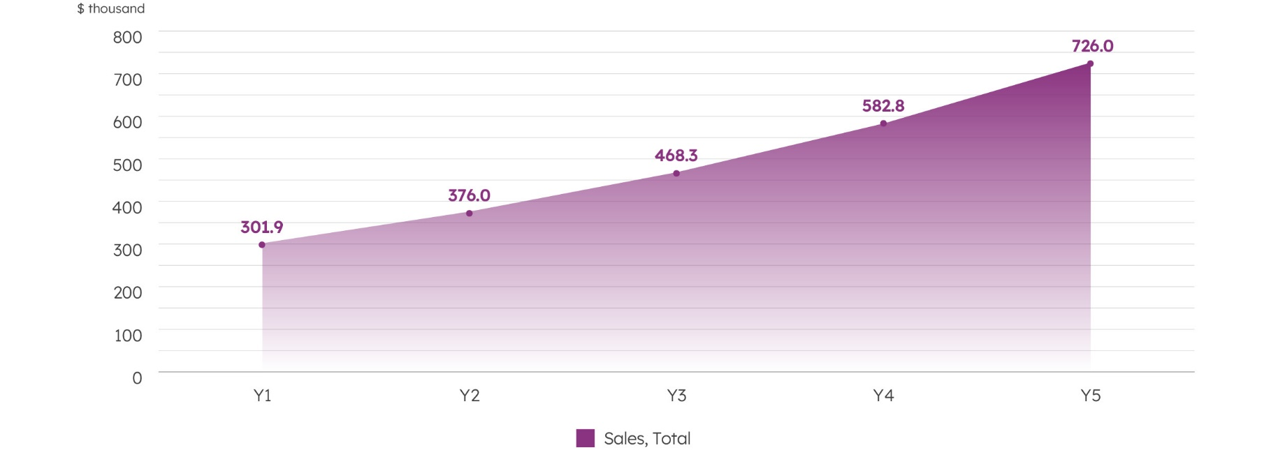
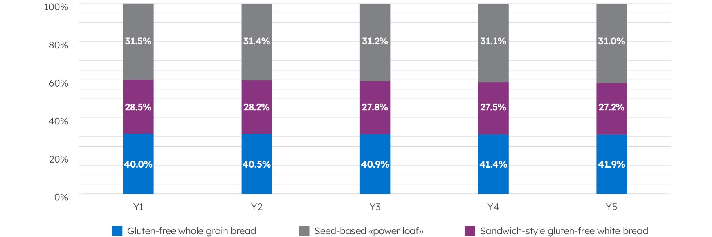
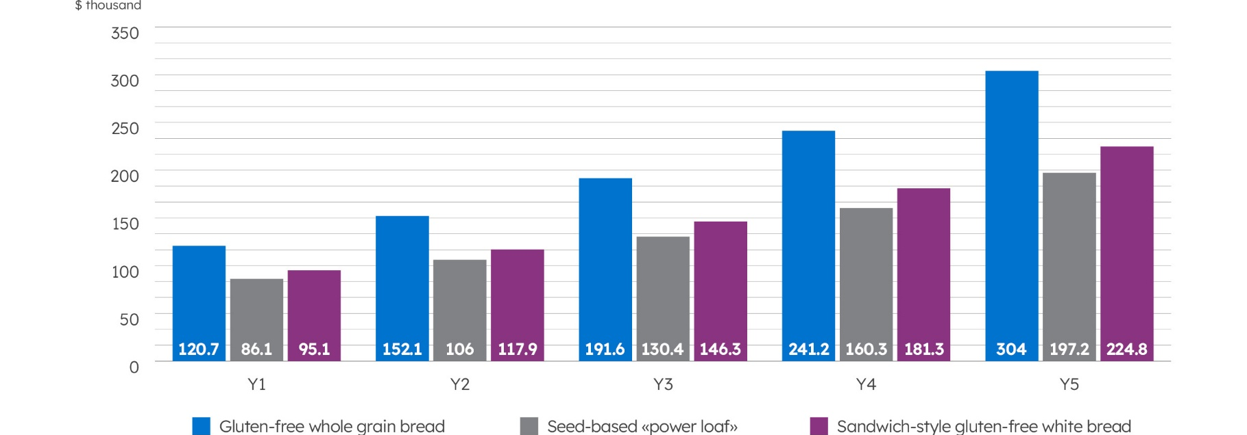
Sales channels
Identify sales channels tailored to target audience. Detail the share of each sales channel in your overall sales distribution and its describtion.
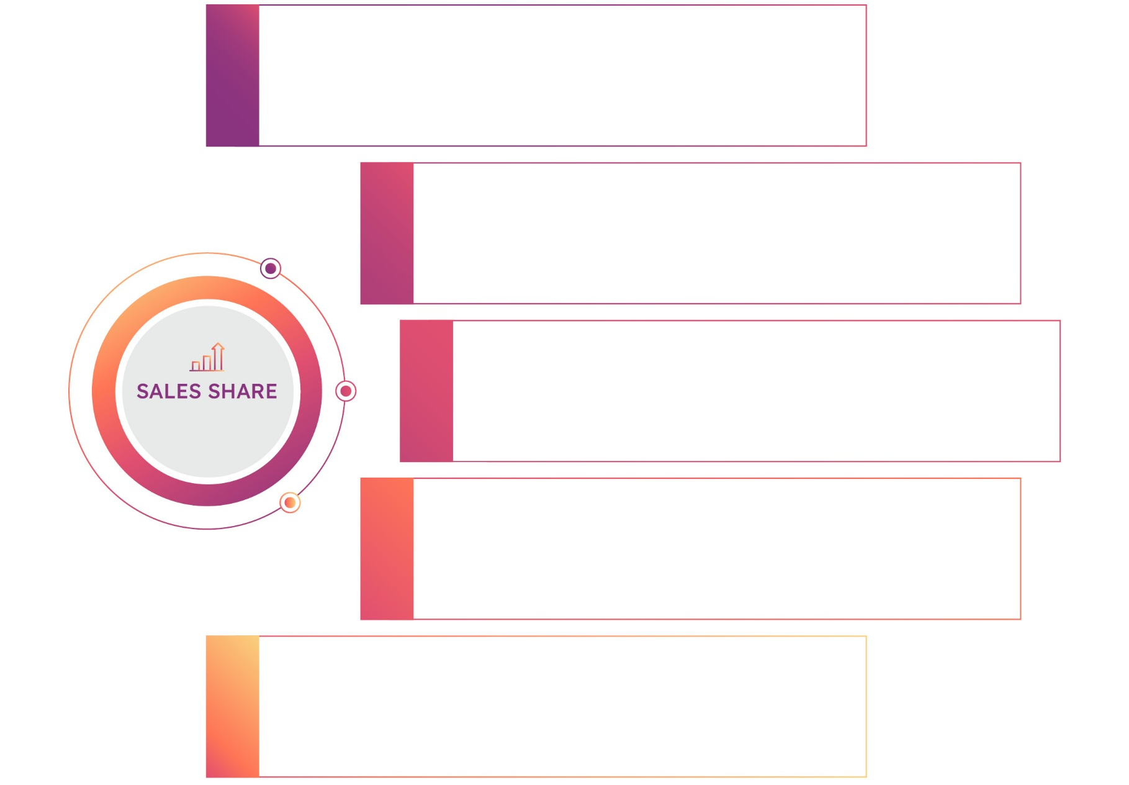
E-commerce Website
A dedicated e-commerce platform will enable direct orders from customers, providing easy access to our full range of gluten-free products.
30%

Social Media Platforms
Active engagement on social media platforms like Instagram and Facebook will help build brand awareness and community.
20%

Neighborhood Storefront
Our physical bakery location will cater to local walk-in customers, creating a welcoming environment for immediate purchases.
25%

Farmers’ Markets
Participation in local farmers’ markets will enhance visibility and allow direct interaction with our target audience.
15%

Partnerships with Health Food Stores
Strategic partnerships with local health food stores will broaden our distribution channels.
10%

  - Marketing Plan
Advertising and Promotion
Articulate the channels and platforms leveraged to reach potential customers. Detail any partnerships, collaborations, or networking efforts contributing to customer acquisition. Convey a comprehensive understanding of your customer acquisition funnel, from initial awareness to conversion, and how your strategies align with the dynamic needs of your target audience.

Start typing here...

Pricing Strategy
Provide a concise overview of the company`s pricing policies. Discuss the pricing strategies you employ, whether cost-plus pricing, value-based pricing, competitive pricing, or a combination of these. Highlight any unique aspects of pricing approach that differentiate you in the market.

Start typing here...


Contents
Template
  - Location and Premises
  - Equipment
  - Technological Process
  - Production
Business Operations
Section 5
Section 5 — Business Operations
- Business Operation
“
This section provides a comprehensive analysis of the key processes and resources required for the successful functioning of the company. It outlines essential components such as the location and premises, equipment, and technological processes involved in production or service provision. It also covers the supply chain, quality control measures, and partnerships with suppliers that ensure operational efficiency. Additionally, this section details the company’s strategies for resource management, inventory control, and outsourcing, along with the specifics of production volumes and seasonality. By addressing these factors, the chapter highlights how your business intends to operate smoothly, meet production goals, and uphold product quality, thus offering valuable insights to potential investors, partners, and stakeholders.”
  - Location and Premises
Future Expansion
Delve into the specifics of the plans for new locations or production facilities. Discuss whether the company is considering constructing new buildings, leasing existing spaces, or entering partnerships for shared facilities.

Start typing here...

  - Equipment
Equipment Usage
Provide a succinct overview of the equipment your business currently possesses. It includes machinery, tools, technology, and other assets crucial to your operations. Clearly state the equipment`s types, models, and capacities, offering a snapshot of the mechanisms that drive your business processes.

Start typing here...

Planned Purchases
Indicate the equipment planned for purchase (name, purpose, number of items in the group, planned cost).

Name of the Group | Reading Bakery Systems Gluten-Free Production Line
Purpose | Complete automated production line specifically designed for gluten-free dough handling with anti-contamination protocols.
Number of Items in the Group | 1
Planned Cost | $150,000
Photo

  - Technological Process
Production Technology
Outline the current technology employed in production or service provision. Emphasize efficiency gains, quality improvements, and competitive advantages.

Start typing here...

Process Stages
Outline key stages of the production process. Provide a step-by-step overview of product or service creation. Briefly describe each stage to offer insight into the technological process.

01 |  | 03 |  | 05
Ingredient Preparation & Mixing |  | Proofing & Fermentation |  | Cooling & Packaging


02 |  | 04
Dough Formation & Shaping |  | Baking & Temperature Control

  - Prodaction
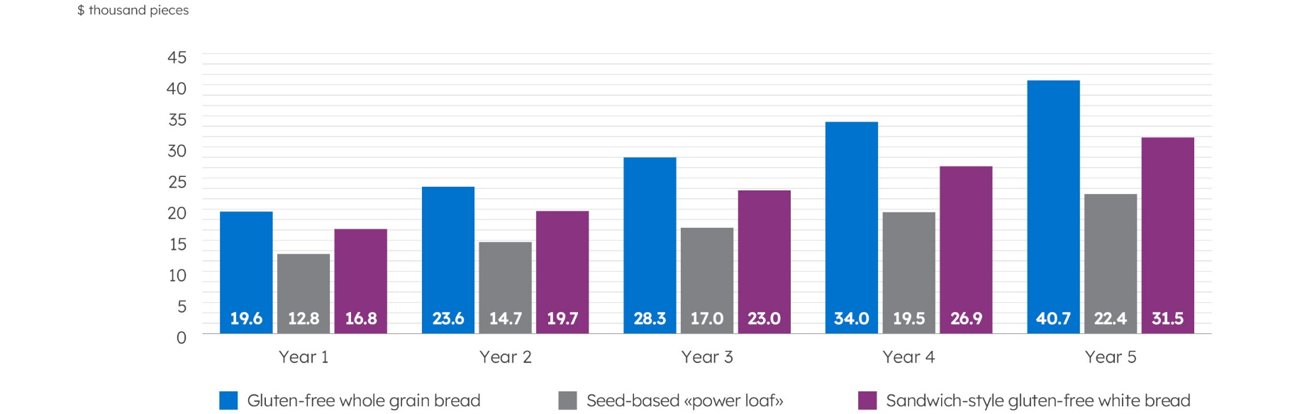
Prodaction Plans
Clearly state the projected volume of products or services that your company aims to produce within a specified timeframe. Provide specific details on the quantity or scale of production, highlighting key metrics such as units, batches, or any relevant measurement.
Production Specifics
Detail seasonal work schedules, addressing fluctuations in demand. Highlight plans for peak season optimization and adjustments in work schedules. Consider regulatory or external dependencies impacting production timelines.

Start typing here...


Contents
Template
Raising
and Allocating Funds
Section 6
Section 6 — Raising and Allocation Funds
- Raising and Allocation Funds
“
This section presents a comprehensive overview of the funding strategy for the project, detailing the total
costs, funding requirements, and resource allocation. By clearly outlining these elements, this section
reassures investors, partners, and stakeholders that the company has a well-structured plan for securing
and managing the financial resources needed to achieve its business objectives.”
Total Project Cost
Conduct a meticulous assessment of the projected expenditures. The comprehensive budgetary analysis should encompass diverse facets such as operational costs, capital expenditures, marketing initiatives, technological investments, and workforce allocations.

Start typing here...

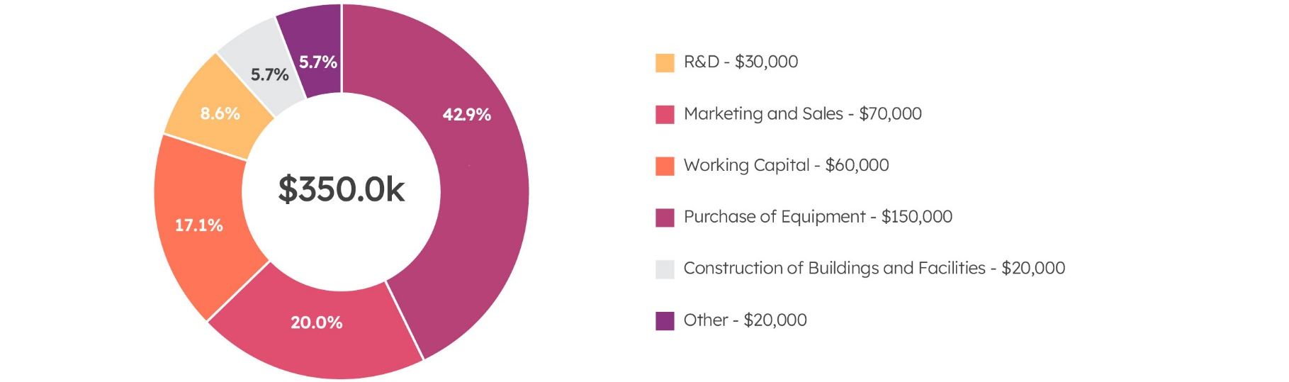
Funding Strategy
Specify budget allocations for each purpose: R&D, Marketing, Working Capital, Construction, Equipment.

Investment Schedule
Articulate a well-defined timeline encompassing critical phases such as initial setup, operational launch, and sustained growth. Align the funding duration with key milestones in the business plan, accounting for market penetration, product development cycles, and revenue generation timelines.

Start typing here...

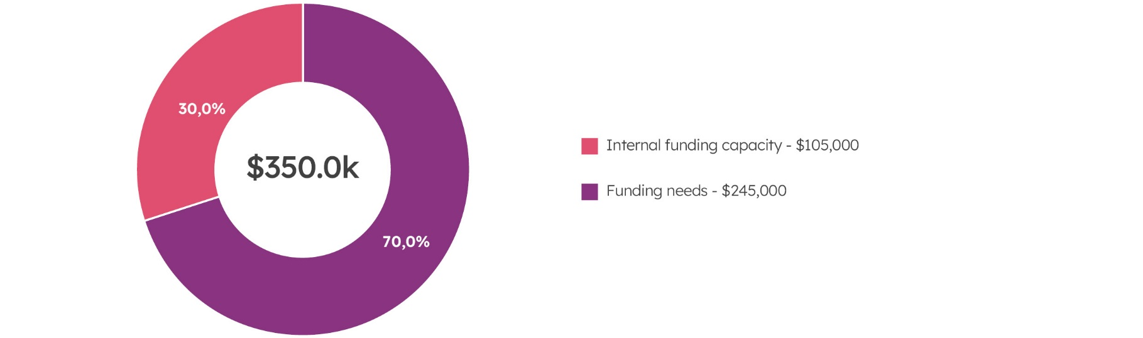
Project Cost
Determine required funding by sources

 | Internal funding capacity  The project has a total cost of $350,000, of which the company will finance 30% internally. This translates to $105,000 being covered by the company’s own funds. The financing will primarily be in cash, although the company may leverage some assets if necessary.
 | Detail the company’s financing strategy. Specify the percentage of project cost to be financed internally. Discuss funding sources such as cash reserves, equity, or asset-based financing. Align financing form with the company’s financial health and risk tolerance for optimal capital structure.
 | Funding needs  The external funding needed amounts to $245,000. This funding gap is critical for securing necessary financing to cover initial operational costs and achieve business viability. To attract potential investors and lenders, Whisk & Bloom Bakery will present a robust business model highlighting market demand for gluten-free products and the bakery’s unique selling propositions, such as ingredient transparency and dedicated production spaces.
Determine required funding by subtracting own funds from total investment. Clearly state the funding gap to secure necessary
external financing.
Investor Terms
Outline the terms offered to investors. Specify aspects like equity stake, dividend policies, voting rights, and exit strategies. Ensure terms align with investor expectations, company valuation, and long-term growth plans to foster mutually beneficial partnerships.

Start typing here...


Contents
Template
  - Key assumptions
  - Profit and Loss Projection
  - Cash Flow Projection
  - Financial performance
Financial
Plan
Section 7
Section 7 — Financial Plan
- Financial Plan
“
This section presents a comprehensive analysis of projected income, expenses, and financial performance ratios, providing valuable insights into anticipated cash flows, balance sheet dynamics, and profit and loss statements. Outlining key assumptions and financial forecasts highlights the project’s financial viability, ensuring that potential investors, partners, and stakeholders clearly understand the economic rationale and long-term sustainability of the business plan.”
  - Key assumptions
Sales assumptions
Sales Growth Factors
Identify the key factors that are expected to drive sales growth. These can include marketing strategies, product launches, distribution channels, customer service improvements, and market expansion. Explain how each factor will contribute to the overall increase in sales.

Start typing here...

Price Changes
State if you expect to change the prices of your products or services during the project period. Explain the reasons for these changes, such as inflation, cost increases, or product improvements. Specify the extent of the price changes.

Start typing here...

Seasonality Impact
Explain how seasonality and economic cycles impact sales volumes. Describe strategies in your plan to manage these fluctuations, like production adjustments and marketing tactics. Highlight diversification efforts to stabilize sales.

Start typing here...

Expenses assumptions
Variable vs. Fixed
Identify and differentiate between variable and fixed expenses. Explain how each type of expense behaves in relation to production levels and business activity. Provide examples of both types of expenses.

Start typing here...

Variable Cost Factors
Identify and explain the primary factors that affect the variable costs of your products or services. Discuss how changes in these factors can impact the overall cost of production.

Start typing here...

R&D Costs
Identify and explain the primary cost components involved in R&D. Include details on personnel salaries, materials and equipment, facility expenses, regulatory compliance, and intellectual property protection.

Start typing here...

Expense Control Strategies
Describe the methods and practices your company uses to manage and reduce operating expenses. Include specific strategies and examples of how these practices are implemented.

Start typing here...

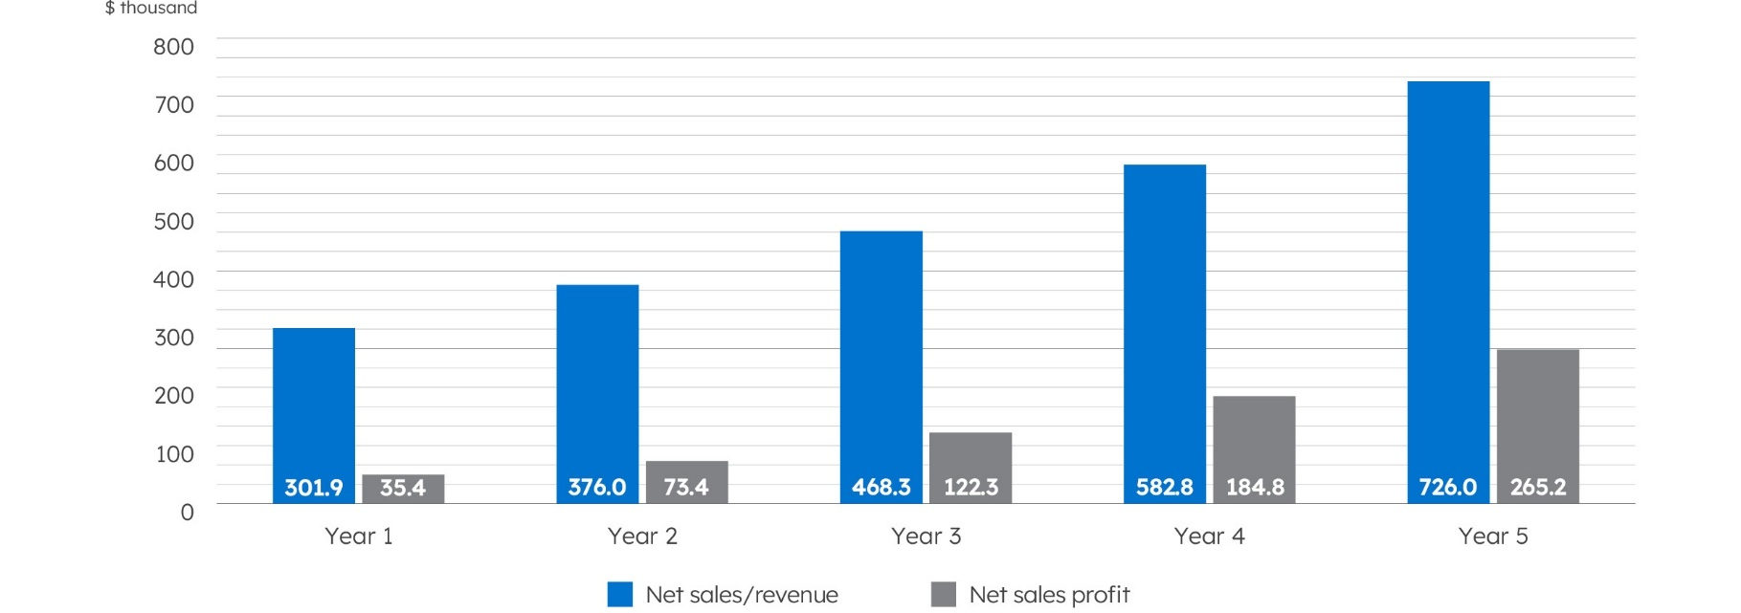
  - Profit and Loss Projection
 |  |  |  |  | thous USD
 | Y1 | Y2 | Y3 | Y4 | Y5
Net Sales/Revenue | 301.9 | 376.0 | 468.3 | 582.8 | 726.0
Gluten-free whole grain bread | 120.7 | 152.1 | 191.6 | 241.2 | 304.0
Seed-based “power loaf” | 86.1 | 106.0 | 130.4 | 160.3 | 197.2
Sandwich-style gluten-free white bread | 95.1 | 117.9 | 146.3 | 181.3 | 224.8
Cost of sales of products/services | 155.8 | 182.3 | 214.6 | 253.9 | 301.9
Gross Profit | 146.1 | 193.6 | 253.6 | 329.0 | 424.2
Operating expenses:
Research and Development (R&D) | 26.5 | 27.8 | 29.2 | 30.6 | 32.2
Sales and marketing | 27.4 | 28.8 | 30.2 | 31.7 | 33.3
General and administrative | 27.4 | 28.8 | 30.2 | 31.7 | 33.3
Other operating expenses | 25.5 | 26.8 | 28.1 | 29.5 | 31.0
Total operating expenses | 106.8 | 112.1 | 117.7 | 123.6 | 129.8
Income tax | 3.9 | 8.2 | 13.6 | 20.5 | 29.4
Net income/profit for the period | 35.4 | 73.4 | 122.3 | 184.8 | 265.0

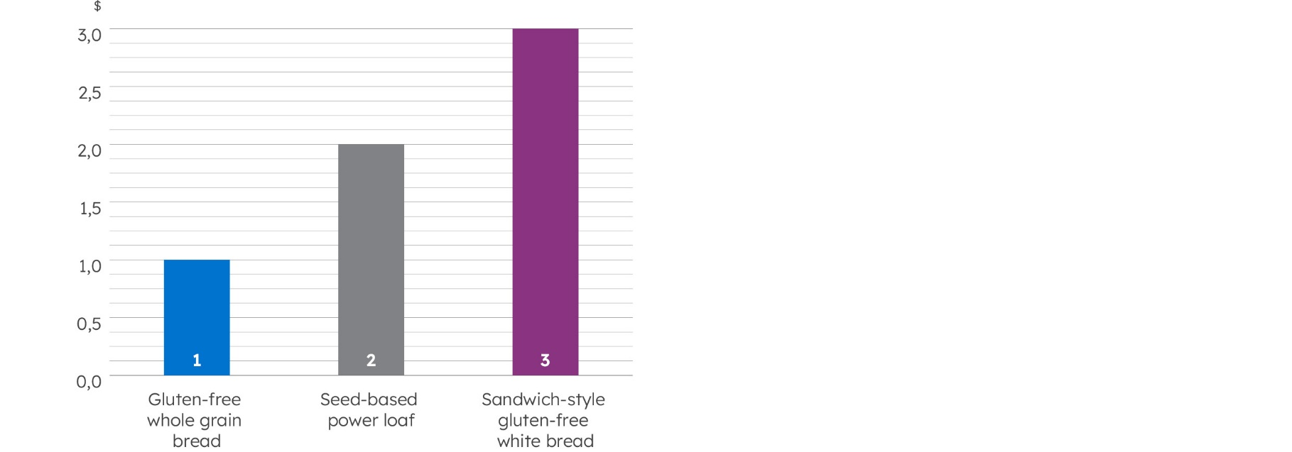
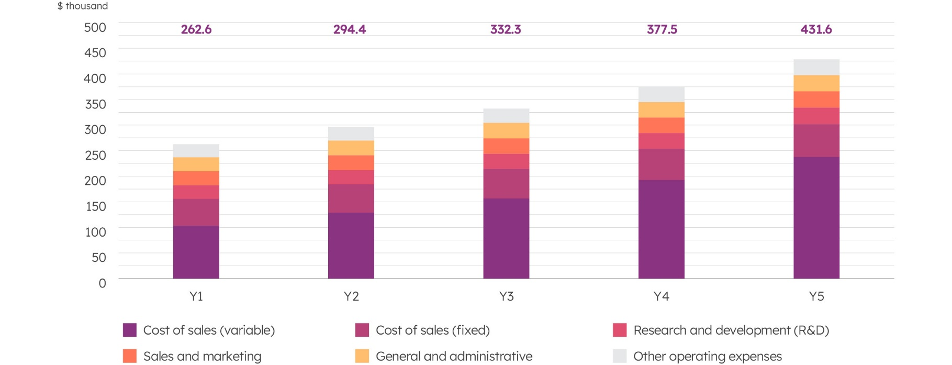
Planned Expenses
 |  |  |  |  | thous USD
 | 1 year | 2 year | 3 year | 4 year | 5 year
Cost of Sales (variable) | 102.9 | 126.8 | 156.3 | 192.6 | 237.6
Cost of Sales (fixed) | 52.9 | 55.6 | 58.3 | 61.2 | 64.3
Research and Development (R&D) | 26.5 | 27.8 | 29.2 | 30.6 | 32.2
Sales and Marketing | 27.4 | 28.8 | 30.2 | 31.7 | 33.3
General and Administrative | 27.4 | 28.8 | 30.2 | 31.7 | 33.3
Other Operating Expenses | 25.5 | 26.8 | 28.1 | 29.5 | 31.0
Total | 262.6 | 294.4 | 332.3 | 377.5 | 431.6
The Initial Cost per Unit of Product/Service

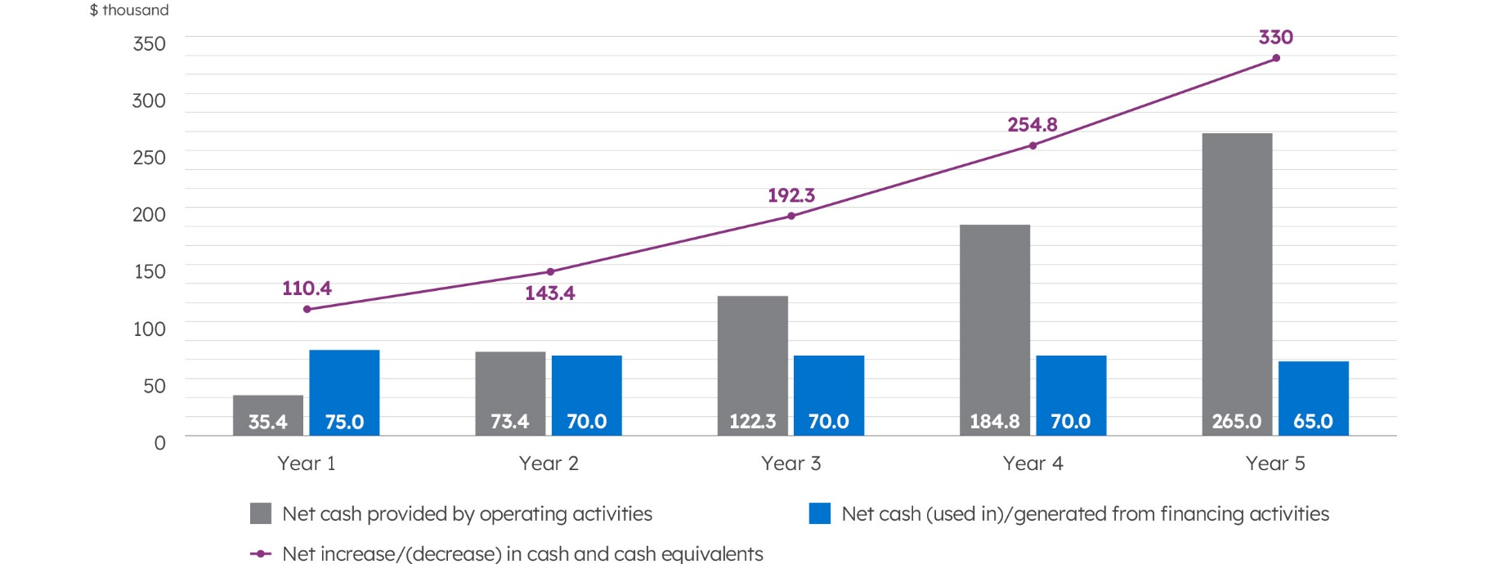
  - Cash Flow Projection
 |  |  |  |  | thous USD
 | 1 year | 2 year | 3 year | 4 year | 5 year
Cash Flows from Operating Activities (direct)
Cash Received from Customers | 301.9 | 376.0 | 468.3 | 582.8 | 726.0
Cash Paid to Suppliers | (237.1) | (267.7) | (304.2) | (347.9) | (400.6)
Cash Paid for Other Operating Expenses | (25.5) | (26.8) | (28.1) | (29.5) | (31.0)
Income taxes paid | (3.9) | (8.2) | (13.6) | (20.5) | (29.4)
Net Cash Provided by Operating Activities | 35.4 | 73.4 | 122.3 | 184.8 | 265.0
Cash Flows from Financing Activities
Proceeds from Issuance of Equity | 75.0 | 70.0 | 70.0 | 70.0 | 65.0
Net Cash (Used in)/Generated from Financing Activities | 75.0 | 70.0 | 70.0 | 70.0 | 65.0
Net Increase/(Decrease) in Cash and Cash Equivalents | 110.4 | 143.4 | 192.3 | 254.8 | 330.0
Cash and Cash Equivalents, Beginning of Period |  | 110.4 | 253.8 | 446.1 | 700.9
Cash and Cash Equivalents, End of Period | 110.4 | 253.8 | 446.1 | 700.9 | 1,030.9

Operating Activities Share
State the share of operating cash flows. Indicate how this share changes over the forecast period, with key factors driving the change. Provide specific figures and reasons for these changes, showing the trend.

Start typing here...

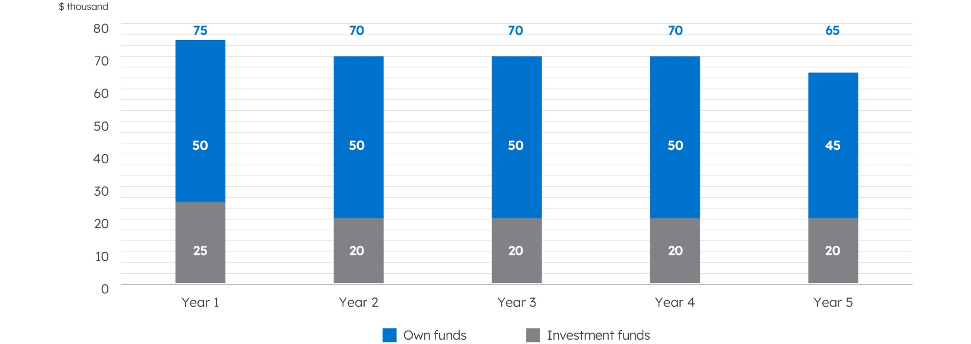
Sources of project financing
  - Financial performance
Investment performance ratios
Ratios | Benchmark Value | The company’s Indicator
ROI (Return on Investment), % | >10 | 194.5
ROE (Return on Equity), % | >15 | 66
ROA (Return on Assets), % | >5 | 66
IRR (Internal Rate of Return), % | >10 | 77
NPV (Net Present Value), thousand $ |  | 192.7
Payback Period | <84 | 32

Investment Performance Ratios
Present the key investment ratios (ROI, ROE, ROA, IRR, NPV, and Payback Period) with their respective values. Briefly explain what each ratio measures and its significance for the project's profitability and efficiency. Highlight the implications of these ratios, indicating the attractiveness and risk level of the investment.

Start typing here...

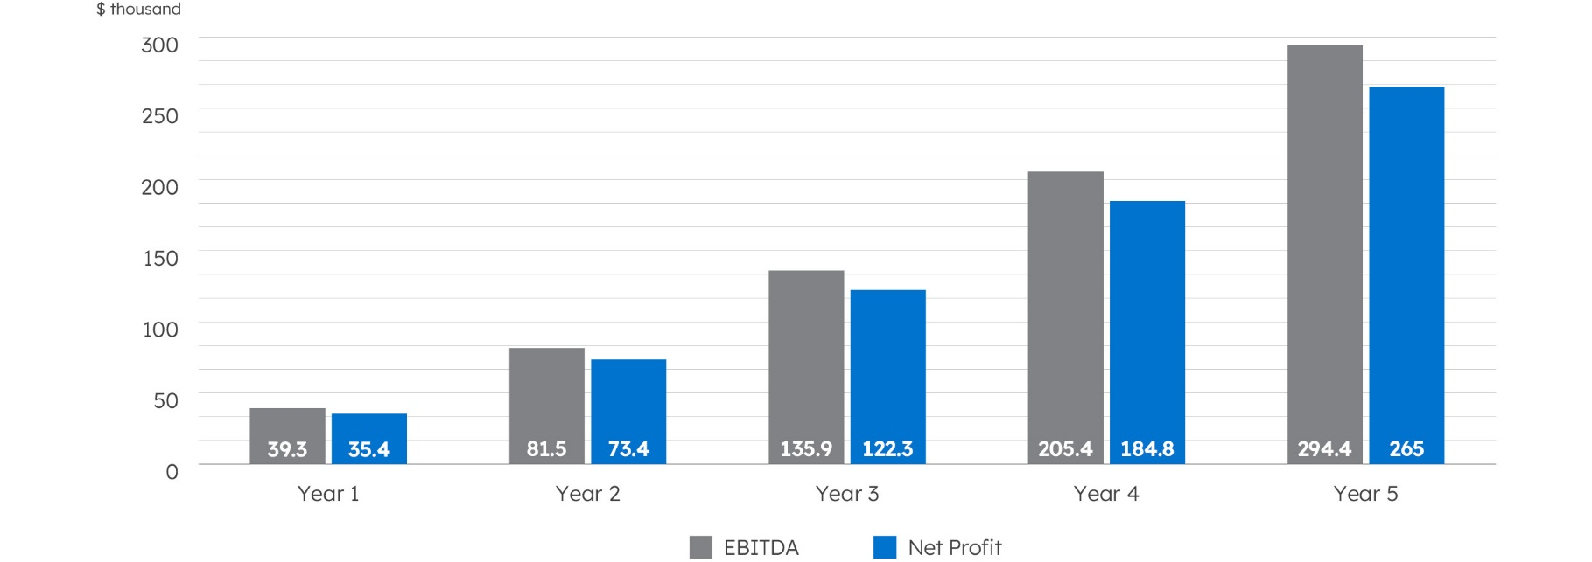
Financial performance
Ratios | Benchmark Value | 1 year | 2 year | 3 year | 4 year | 5 year
Profitability ratios
Gross Margin, % | >30 | 48.4 | 51.5 | 54.2 | 56.4 | 58.4
Net Profit Margin, % | 5-20 | 11.7 | 19.5 | 26.1 | 31.7 | 36.5
EBITDA, thousand $ |  | 39.3 | 81.5 | 135.9 | 205.4 | 294.4
Net Profit, thousand $ |  | 35.4 | 73.4 | 122.3 | 184.8 | 265
Profitability ratios

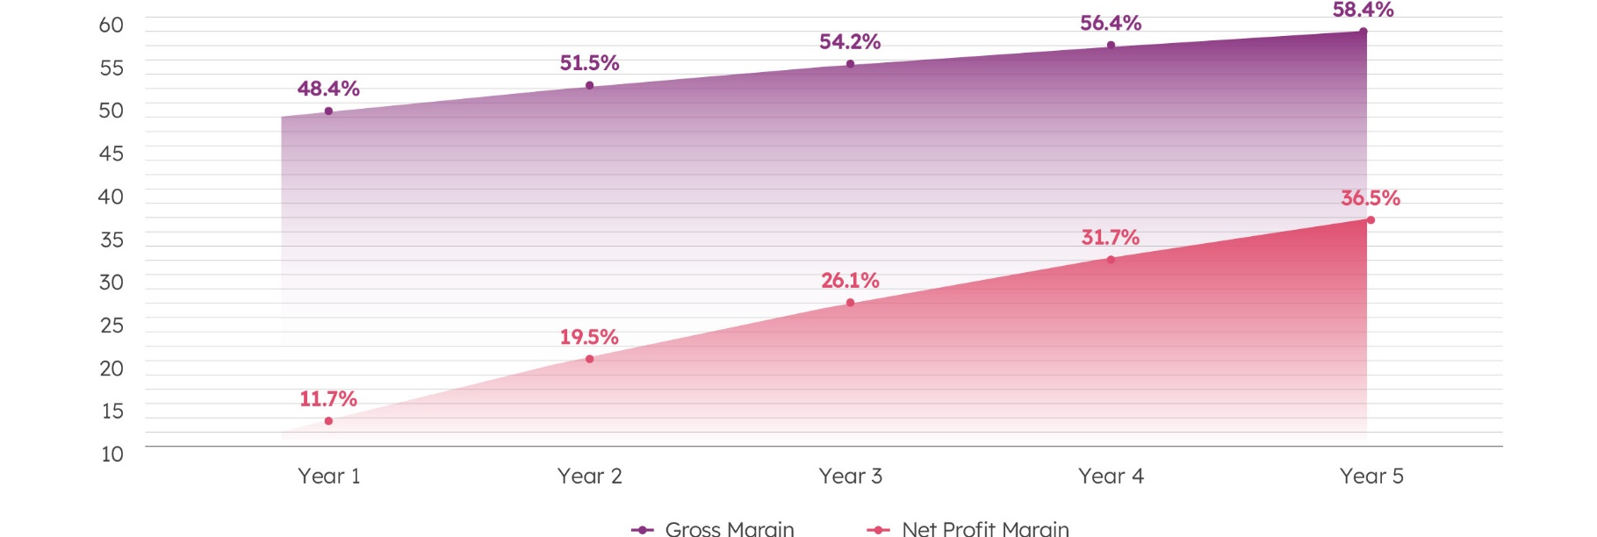
Profitability ratios
List the key profitability ratios and their forecasted values. Explain the significance of each ratio and its anticipated improvement over the forecast period. Highlight the reasons behind the expected changes and what they indicate about the company's performance.

Start typing here...






Your address here
Brandname.com
Email@.com
Your address here

