

[Company Name]
[The business plan title]
01 | Summary
1.1. | Goals And Objectives
1.2. | Company Description
1.3. | Products/Services
1.4. | Market And Customers
1.5. | Financing Needs
02 | About the Company
2.1. | General Company Information
2.2. | About the Project
2.3 | Implementation Plan
2.4. | SWOT Analysis
03 | Market Analysis
3.1. | Market Overview
3.2. | Competitive Analysis
3.3. | Consumer Needs
04 | Marketing and Sales
4.1. | Sales Plan
4.2. | Marketing Plan
05 | Business Operations
5.1. | Location And Premises
5.2. | Equipment
5.3. | Production
5.4. | Products/Services Description
06 | Management and Organization
6.1. | Management Team
6.2. | Staff Organization
07 | Raising and Allocating Funds
08 | Financial Plan
8.1. | Key Assumptions
8.2. | Profit and Loss Projection
8.3. | Projected Cash Flow
8.4. | Financial Performance

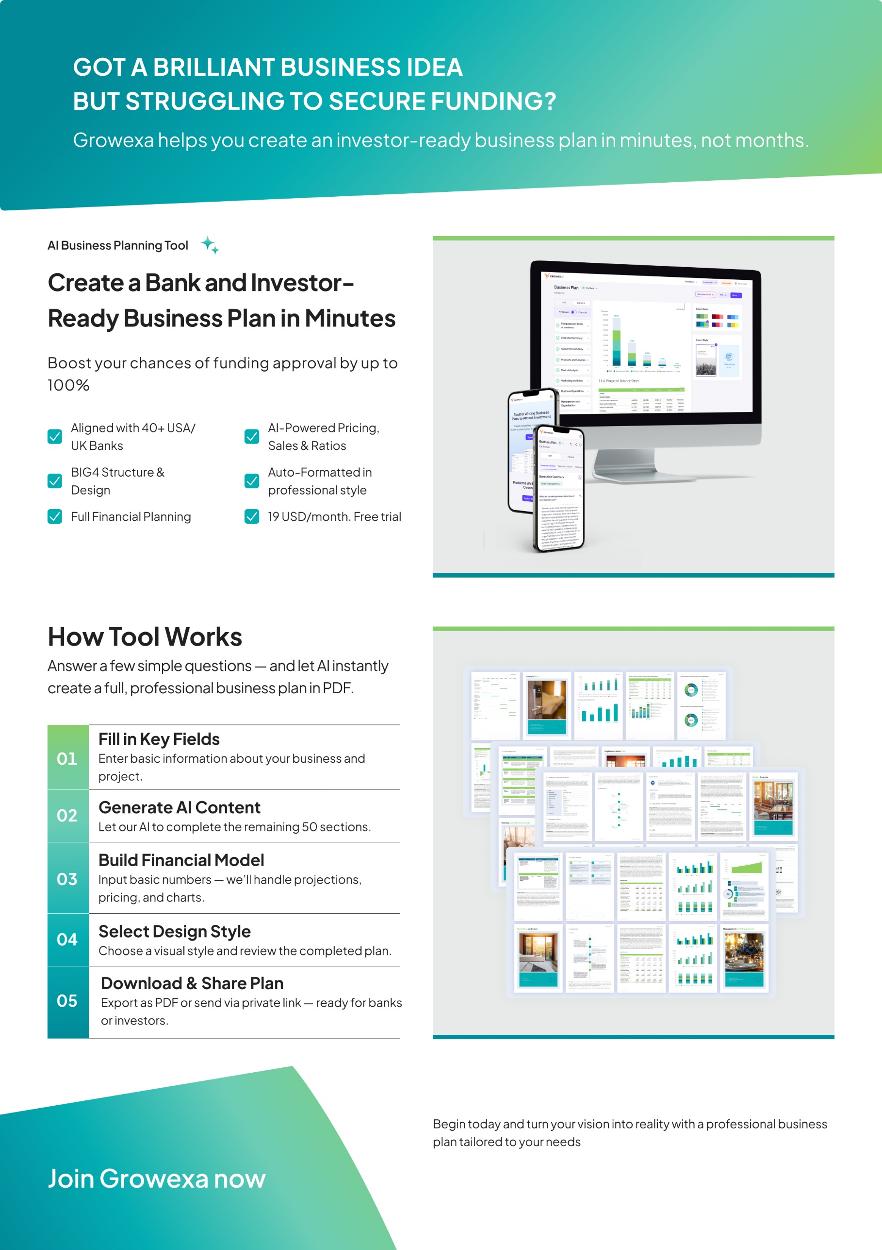
Start your business plan now
Start 3-day free trial
Start 3-day free trial

Template
Contents
  - Goals and Objectives
  - Company Description
  - Products or Services
  - Market and Customers
  - Financing Needs

Summary

Section 1
Section 1 — Summary
- Summary
“
This section offers a concise, comprehensive overview of the business plan, highlighting the project’s key elements and strategic direction. It is critical for providing potential investors, partners, and stakeholders with a clear, high-level understanding of the business and its overall strategic vision. This summary serves as a foundation, outlining the primary goals and roadmap of the business in a way that captures interest and sets the stage for deeper engagement with the rest of the plan.”
  - Goals and Objectives
Main Goals and Objectives
Outline company strategic goals, emphasizing short, medium, long-term objectives aligned with mission and vision. Specify focus areas like market expansion, revenue growth, or product innovation. Discuss strategies, initiatives, KPIs driving goal realization.

Start typing here...

Description of the Project
Succinctly describe investment project essence, be it new facility, modernization, or market expansion. Briefly introduce target business, its industry, market presence, core products, financial health, and strengths, outlining acquisition rationale.

Start typing here...

  - Company Description
Company Name
Provide the intended full and official name of your company. If the company is not yet registered, ensure the name reflects your brand vision and planned official registration.

Start typing here...

Registration Date
State the precise date when your company was officially registered, include the year, month, and day of registration.

Start typing here...

Operating Sector
Specify the sector your company operates in, selecting the appropriate level of detail from the provided dropdown options.

Start typing here...

Mission Statement
Define company mission, stating purpose and values. Highlight impact on marketplace or community, emphasizing unique value proposition. Align mission with broader goals, express commitment to principles like innovation, customer service, or sustainability.

Start typing here...

Address of registration
Specify the city and country where your company is officially registered. Provide accurate details to facilitate legal inquiries or business transactions.

Start typing here...

  - Products or Services
Main products/services offered
Introduce your product with an attention-grabbing statement, highlighting its primary purpose and key distinguishing features briefly yet compellingly.

Start typing here...

Product/service development plans
Articulate your organization’s strategic vision for product development and expansion, detailing future research initiatives and potential new product categories or sectors.

Start typing here...

  - Market and Customers
Target market and consumption
Provide concise market overview: needs, preferences, pain points addressed. Highlight unique aspects like geographic concentration. Estimate market size citing sources. Emphasize economic value and business opportunities.

Start typing here...

Sales Channels
Overview primary distribution channels: direct sales, retail, e-commerce. Discuss rationale, considering reach, preferences, industry standards. Address channel-specific advantages and challenges.

Start typing here...

Main competitors
Analyze competitive landscape: main competitors, market share, offerings, reach. Discuss distinctive characteristics or advantages.

Start typing here...

Financing needs
Total Project Cost
Conduct a meticulous assessment of the projected expenditures. The comprehensive budgetary analysis should encompass diverse facets such as operational costs, capital expenditures, marketing initiatives, technological investments, and workforce allocations.
Funding needs
Determine the required funding by conducting a comprehensive assessment of all project expenses and anticipated costs.
Funding by own funds
Specify the percentage of project cost to be financed internally.
Funding directions
Specify budget allocations for each purpose: R&D, Marketing, Working Capital, Construction, Equipment.


Section 2 — About the Company
Contents
Template
  - General Company Information
  - About the Project
  - Implementation Plan
  - SWOT Analysis

About
the Company
Section 2
- About the Company
“
This section offers a detailed company overview, covering its mission, vision, history, and strategic direction. It aims to establish the company's credibility and strategic focus, providing potential investors, partners, and stakeholders with a clear understanding of the business and its growth potential. By outlining the company's foundation and future outlook, this section demonstrates its stability and long-term prospects, reinforcing confidence in its ability to succeed.”
  - General Company Information
Company Brief
Specify a concise company overview. Delve into the distinctive features that set your company apart. Emphasize proprietary technologies, innovative approaches, or unique capabilities contributing to a competitive advantage.

Start typing here...

Name
Provide the intended full and official name of your company. If the company is not yet registered, ensure the name reflects your brand vision and planned official registration.
Legal Structure
State the legal structure of your company. Options include sole proprietorship, partnership, corporation, or limited liability company (LLC).
Operating industry
Specify the sector your company operates in, selecting the appropriate level of detail from the provided dropdown options.
Number of employees
Provide an accurate count of your company’s current employees, including full-time, part-time, and contract workers
Address of registration
Specify the city and country where your company is officially registered. Provide accurate details to facilitate legal inquiries or business transactions.
Registration date
State the precise date when your company was officially registered, include the year, month, and day of registration.
Website
Share your company's full web address
E-mail
Provide the official email address of the company accurately, include the domain name and any relevant department or contact details.

  - About the Project
Description of the Project
Succinctly describe investment project essence, be it new facility, modernization, or market expansion. Briefly introduce target business, its industry, market presence, core products, financial health, and strengths, outlining acquisition rationale.

Start typing here...

Main goals and objectives
Outline company strategic goals, emphasizing short, medium, long-term objectives aligned with mission and vision. Specify focus areas like market expansion, revenue growth, or product innovation. Discuss strategies, initiatives, KPIs driving goal realization.

Goal | Priority | Terms | Mechanism of achievement
Long-term
Short-term

Problem Definition
Briefly outline market context and specific problem or need. Articulate industry challenges, emphasizing impact on stakeholders. Identify market gaps creating opportunity for business.

Start typing here...

Contribution to Problem Solving
State business plan subject, highlighting unique solution elements. Outline core features, emphasizing problem-solving approach. Discuss strategic approach, including innovative tech or value propositions. Articulate benefits and outcomes for stakeholders.

Start typing here...

  - Implemenation Plan
Identify the main preparatory stages for implementing the business plan

 | 06.2025 | 07.2025 | 08.2025 | 09.2025 | 12.2025
Stage1
Stage2
Stage3
Stage4
Stage5

 | Done |  | In Progress |  | To do

  - SWOT Analysis
Strengths |  | Weaknesses
Identify core competencies and resources giving market edge. Highlight specialized skills, unique capabilities, and brand reputation. |  | Identify company`s internal limitations and challenges. Transparently discuss areas needing improvement: processes, resources, skills. Address gaps in meeting industry benchmarks, operational inefficiencies, and their impact on performance and competitiveness.
Opportunities |  | Threats
Analyze market trends and identify opportunities matching company strengths. Discuss consumer shifts, tech advancements, and regulations. Explore leveraging these trends for market expansion, new offerings, or entering untapped segments. |  | Identify and analyze external threats: market trends, competition, economic downturns, regulatory uncertainties. Discuss impact on operations, market share, customer relationships. Articulate potential negative consequences and vulnerabilities.


Contents
Template
  - Market Overview
  - Competitive Analysis
  - Consumer Needs
Market
analysis
Section 3
Section 3 — Market Analysis
- Market Overview
“
This section thoroughly analyses the market environment in which your business operates, encompassing key trends, consumer behaviours, and the competitive landscape. It provides a detailed examination of how your product or service integrates into the current market structure, addressing aspects such as present and future demand, pricing strategies, and competitive positioning. By illuminating these components, this section aids potential investors and stakeholders assess the market potential and strategic opportunities available to your business.”
  - Market Overview
Consumption Analysis
Describe consumption trends using statistics. Present actual data and forecasted figures, highlighting growth trajectories and market dynamics.

Start typing here...


Consumption Forecast
Specify the actual and forecasted consumption in the market (product/service/other market segment/year/unit (volume/currency).

Sales Strategy
Describe sales channels for the product/service. Detail online platforms, retail partnerships, and direct sales strategies to reach target customers effectively.

Start typing here...

Trend Name
Identify the main market trends. Ensure the trends are relevant to your industry and reflect current market dynamics.

01 | Trend  Description
02 | Trend  Description
03 | Trend  Description

04 | Trend  Description
05 | Trend  Description
  - Competition Analysis
Competitor Identification
List direct and indirect competitors, explaining their relevance. Highlight similarities in offerings, target markets, and distribution channels, emphasizing competitive advantages and market positioning.

Start typing here...

Competior Comparison
Compare your key competitors (name/logo/location/website/brief description of the product/positioning/sales channels/pricing policy/annual sales volume/market share/customer loyalty level).

Name | Competitor 1 | Competitor 2
Logo
Location
Website
Brief description
of the product
Positioning
Sales channels
Pricing policy
Annual sales volume
Market share
Customer Loyalty Level

  - Consumer Needs
B2C Consumer Profile
Describe the key consumer profile (B2C) (gender/age/income/profession/personal interests/purchasing habits/needs and problems).

Gender
Age
Income
Profession
Personal interests
Purchasing habits
Needs and problems
Market Satisfaction
Provide an overview of the current customer satisfaction levels within the market. Discuss the overall sentiment of customers toward existing offerings and services. Highlight specific areas where customers express satisfaction and those where improvements are needed. It could include product features, service quality, pricing, or other factors influencing customer perceptions.

Start typing here...


Contents
Template
  - Sales Plan
  - Marketing Plan
Marketing
and Sales
Section 4
Section 4 — Marketing and Sales
- Marketing and Sales
“
This section outlines the company's strategic approach to marketing and sales. It details the planned initiatives for marketing, brand positioning, and sales strategies aimed at reaching and engaging the target audience. By describing the advertising campaigns, pricing strategies, sales processes, and tools for customer relationship management, this section illustrates how the company intends to drive revenue growth and establish a competitive position in the market.”
  - Sales Plan
Sales Goals
Outline short-term and long-term sales objectives. Define achievable targets within specific timeframes, considering market trends, competition, and growth projections.

Start typing here...

Sales Plan Details
Provide the sales plan broken down by products/services

 | Y1 | Y2 | Y3 | Y4 | Y5
Product1/Service1
In physical, pieces thousand
Selling Price, $/pieces
In monetary, $ thousand
Product1/Service2
In physical, pieces thousand
Selling Price, $/pieces
In monetary, $ thousand
Product1/Service3
In physical, pieces thousand
Selling Price, $/pieces
In monetary, $ thousand
Total, $ thousand



Sales channels
Identify sales channels tailored to target audience. Detail the share of each sales channel in your overall sales distribution and its describtion.
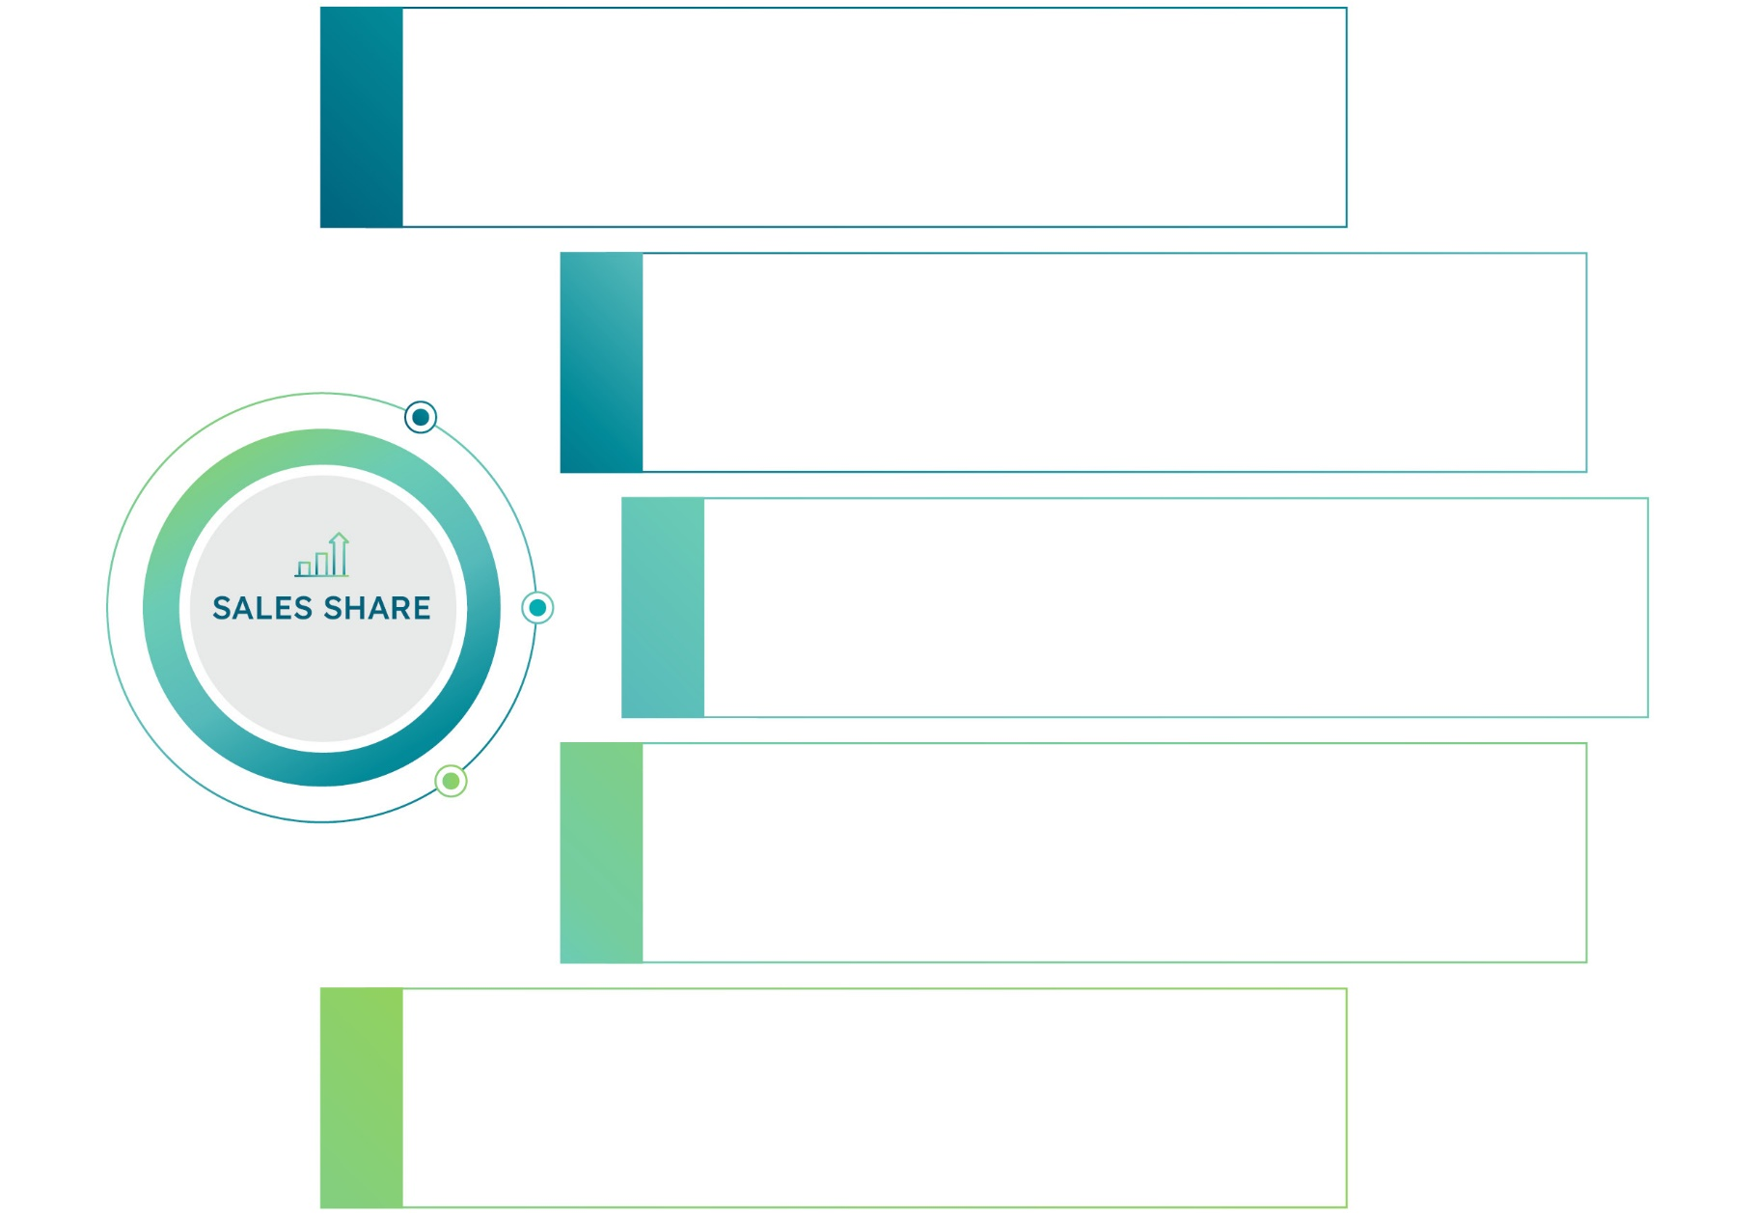

01

02

03

04

05

  - Marketing Plan
Advertising and Promotion
Articulate the channels and platforms leveraged to reach potential customers. Detail any partnerships, collaborations, or networking efforts contributing to customer acquisition. Convey a comprehensive understanding of your customer acquisition funnel, from initial awareness to conversion, and how your strategies align with the dynamic needs of your target audience.

Start typing here...

Pricing Strategy
Provide a concise overview of the company`s pricing policies. Discuss the pricing strategies you employ, whether cost-plus pricing, value-based pricing, competitive pricing, or a combination of these. Highlight any unique aspects of pricing approach that differentiate you in the market.

Start typing here...


Contents
Template
  - Location and Premises
  - Equipment
  - Technological Process
  - Products/Services Description
Business Operations
Section 5
Section 5 — Business Operations
- Business Operation
“
This section provides a comprehensive analysis of the key processes and resources required for the successful functioning of the company. It outlines essential components such as the location and premises, equipment, and technological processes involved in production or service provision. It also covers the supply chain, quality control measures, and partnerships with suppliers that ensure operational efficiency. Additionally, this section details the company’s strategies for resource management, inventory control, and outsourcing, along with the specifics of production volumes and seasonality. By addressing these factors, the chapter highlights how your business intends to operate smoothly, meet production goals, and uphold product quality, thus offering valuable insights to potential investors, partners, and stakeholders.”
  - Location and Premises
Future Expansion
Delve into the specifics of the plans for new locations or production facilities. Discuss whether the company is considering constructing new buildings, leasing existing spaces, or entering partnerships for shared facilities.

Start typing here...

  - Equipment
Planned Purchases
Indicate the equipment planned for purchase (name, purpose, number of items in the group, planned cost).

Name of the Group
Purpose
Number of Items in the Group
Planned Cost
Photo

Name of the Group
Purpose
Number of Items in the Group
Planned Cost
Photo
  - Production

Production Plans
Clearly state the projected volume of products or services that your company aims to produce within a specified timeframe. Provide specific details on the quantity or scale of production, highlighting key metrics such as units, batches, or any relevant measurement.
Production Specifics
Detail seasonal work schedules, addressing fluctuations in demand. Highlight plans for peak season optimization and adjustments in work schedules. Consider regulatory or external dependencies impacting production timelines.

Start typing here...

  - Products/Services Description
Products/services Overview
Present a structured list of your products or services. Group them into categories or highlight any flagship offerings that define your business. Emphasize the essential characteristics or qualities that set your products or services apart from competitors, such as innovation, quality, or unique features.

Start typing here...

Product/Service Characteristics
Enumerate the key features of the product concisely, highlighting its main functionalities and benefits.

Sunrise Bistro & Grill

Characteristic1
Description
01
Characteristic2
Description
02
Characteristic3
Description
03
Characteristic4
Description
04
Characteristic5
Description
05


Contents
6.1 Management Team
6.2 Staff Organization
Management
and Organization
Section 6
Section 6 — Raising and Allocation Funds
- Management and Organization
“
This section delves into the composition and competencies of the management team, the external partners and advisers supporting the company, and the organizational structure, recruitment practices, and strategies for employee retention and development that are crucial for maintaining operational efficiency and achieving long-term growth. ”
  - Management Team
History and Background
Detail the formation history of your management team. Describe the process of assembling the team, the key stages, roles, backgrounds and contributions of each team member. Highlight the expertise and experience brought by each member.

Start typing here...

Key Personnel Profiles
Create profiles for key personnel (photo, name and surname, date of birth, current position, education (name of the institution and specialization), work experience (period, name of the employer, position, functions), key skills, special achievements).

Photo |  | Education  Work Experience  Functions  Key Skills  Special Achievements
Name
Surname
Current Position

Photo |  | Education  Work Experience  Functions  Key Skills  Special Achievements
Name
Surname
Current Position

Photo |  | Education  Work Experience  Functions  Key Skills  Special Achievements
Name
Surname
Current Position

  - Staff Organization
Staff Number & Structure
Provide a snapshot of the current employee count within the company. Specify the total number of employees and briefly outline the composition of the workforce, highlighting any key departments or teams.

Start typing here...

Organizational structure
Present the organizational structure (name of the department, interrelations).


Level 1


Level 1 |  | Level 2 |  | Level 3 |  | Level 4

Skills and Qualifications
List the skills and qualifications you believe are necessary for your company`s employees to perform their roles. Include technical skills, education and relevant experience. Be concise and specific.

Start typing here...

Hiring Needs
Identify the types and numbers of staff required to implement the project. Outline the roles, skills, and expertise needed to support the project`s development.

Start typing here...

Salary and Motivation
Detail your salary policy relative to the market. Describe existing motivation programs, including bonuses, profit sharing, and recognition initiatives. Outline any performance measures or targets associated with incentives.

Start typing here...


Contents
Template
Raising
and Allocating Funds
Section 7
Section 7 — Raising and Allocation Funds
- Raising and Allocation Funds
“
This section presents a comprehensive overview of the funding strategy for the project, detailing the total
costs, funding requirements, and resource allocation. By clearly outlining these elements, this section
reassures investors, partners, and stakeholders that the company has a well-structured plan for securing
and managing the financial resources needed to achieve its business objectives.”
Total Project Cost
Conduct a meticulous assessment of the projected expenditures. The comprehensive budgetary analysis should encompass diverse facets such as operational costs, capital expenditures, marketing initiatives, technological investments, and workforce allocations.

Start typing here...


Funding Strategy
Specify budget allocations for each purpose: R&D, Marketing, Working Capital, Construction, Equipment.

Investment Schedule
Articulate a well-defined timeline encompassing critical phases such as initial setup, operational launch, and sustained growth. Align the funding duration with key milestones in the business plan, accounting for market penetration, product development cycles, and revenue generation timelines.

Start typing here...


Project Cost
Determine required funding by sources

 | Internal funding capacity  Description
 | Detail the company’s financing strategy. Specify the percentage of project cost to be financed internally. Discuss funding sources such as cash reserves, equity, or asset-based financing. Align financing form with the company’s financial health and risk tolerance for optimal capital structure.
 | Funding needs  Description
Determine required funding by subtracting own funds from total investment. Clearly state the funding gap to secure necessary
external financing.
Investor Terms
Outline the terms offered to investors. Specify aspects like equity stake, dividend policies, voting rights, and exit strategies. Ensure terms align with investor expectations, company valuation, and long-term growth plans to foster mutually beneficial partnerships.

Start typing here...


Contents
Template
  - Key assumptions
  - Profit and Loss Projection
  - Cash Flow Projection
  - Financial performance
Financial
Plan
Section 8
Section 8 — Financial Plan
- Financial Plan
“
This section presents a comprehensive analysis of projected income, expenses, and financial performance ratios, providing valuable insights into anticipated cash flows, balance sheet dynamics, and profit and loss statements. Outlining key assumptions and financial forecasts highlights the project’s financial viability, ensuring that potential investors, partners, and stakeholders clearly understand the economic rationale and long-term sustainability of the business plan.”
  - Key assumptions
Sales assumptions
Sales Growth Factors
Identify the key factors that are expected to drive sales growth. These can include marketing strategies, product launches, distribution channels, customer service improvements, and market expansion. Explain how each factor will contribute to the overall increase in sales.

Start typing here...

Price Changes
State if you expect to change the prices of your products or services during the project period. Explain the reasons for these changes, such as inflation, cost increases, or product improvements. Specify the extent of the price changes.

Start typing here...

Expenses assumptions
Variable vs. Fixed
Identify and differentiate between variable and fixed expenses. Explain how each type of expense behaves in relation to production levels and business activity. Provide examples of both types of expenses.

Start typing here...

Variable Cost Factors
Identify and explain the primary factors that affect the variable costs of your products or services. Discuss how changes in these factors can impact the overall cost of production.

Start typing here...

Expense Control Strategies

Describe the methods and practices your company uses to manage and reduce operating expenses. Include specific strategies and examples of how these practices are implemented.

Start typing here...

Expense Control Strategies
Describe the methods and practices your company uses to manage and reduce operating expenses. Include specific strategies and examples of how these practices are implemented.

Start typing here...

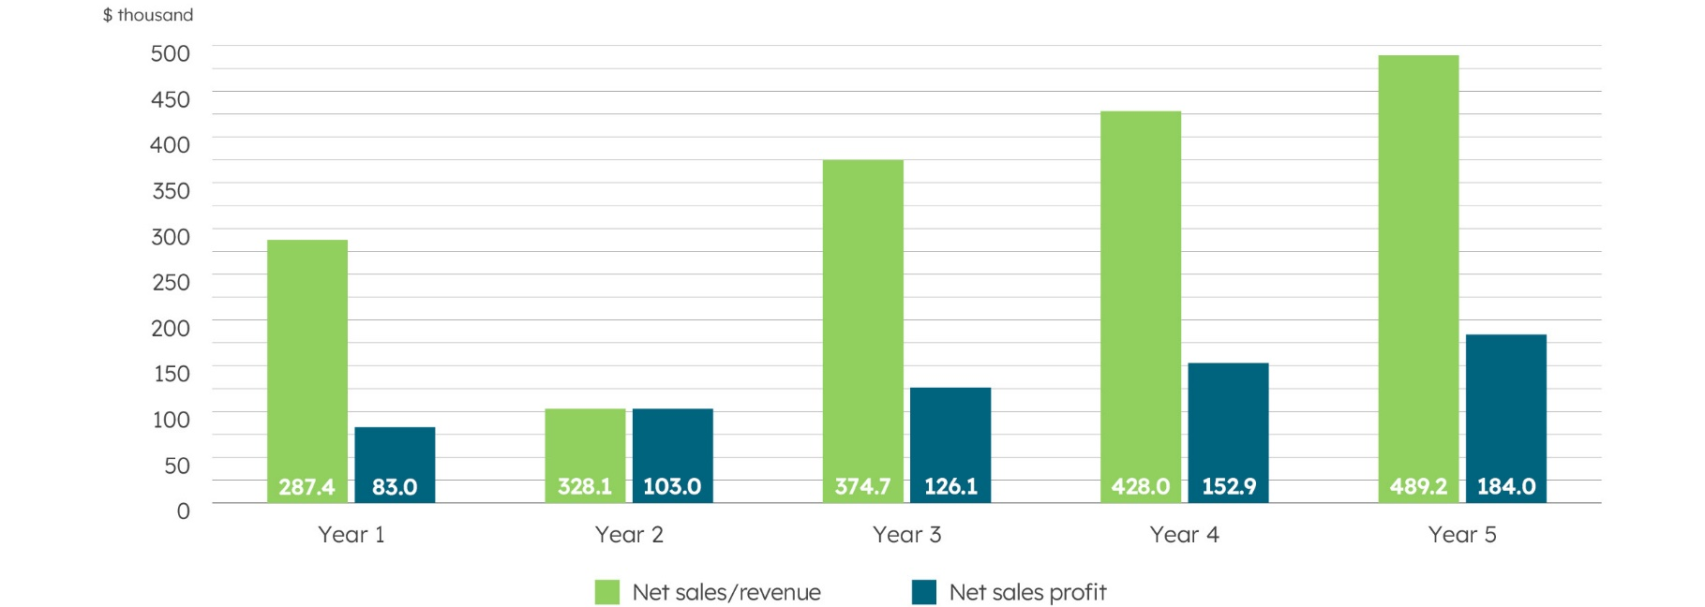
  - Profit and Loss Projection
 |  |  |  |  | thous USD
 | Y1 | Y2 | Y3 | Y4 | Y5
Net Sales/Revenue
Product/Service 1
Product/Service 2
Product/Service 3
Cost of sales of products/services
Gross Profit
Operating expenses:
Research and Development (R&D)
Sales and marketing
General and administrative
Other operating expenses
Total operating expenses
Income tax
Net income/profit for the period

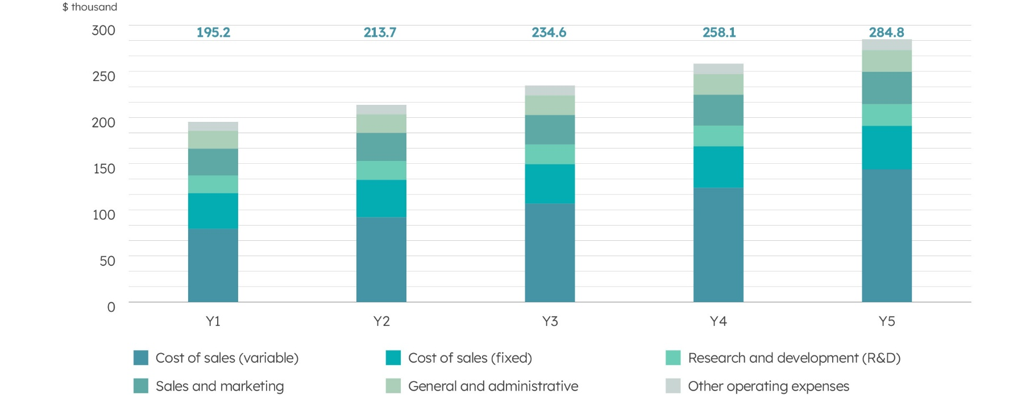
Planned Expenses
 |  |  |  |  | thous USD
 | 1 year | 2 year | 3 year | 4 year | 5 year
Cost of Sales (variable)
Cost of Sales (fixed)
Research and Development (R&D)
Sales and Marketing
General and Administrative
Other Operating Expenses
Total
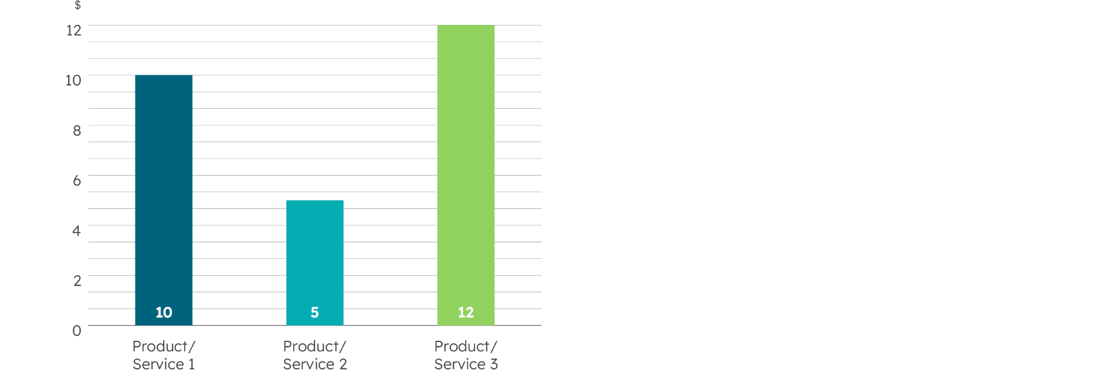
The Initial Cost per Unit of Product/Service

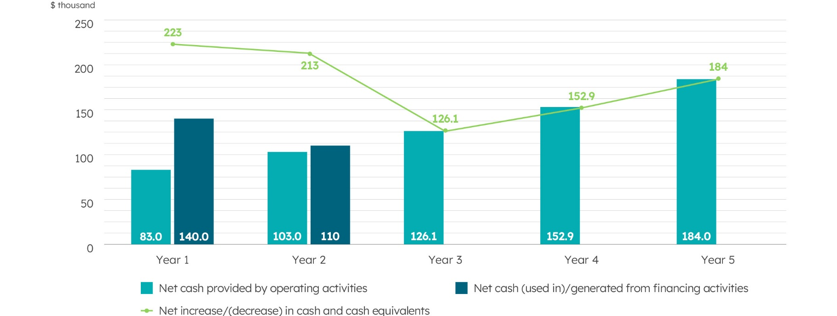
  - Cash Flow Projection
 |  |  |  |  | thous USD
 | 1 year | 2 year | 3 year | 4 year | 5 year
Cash Flows from Operating Activities (direct)
Cash Received from Customers
Cash Paid to Suppliers
Cash Paid for Other Operating Expenses
Income taxes paid
Net Cash Provided by Operating Activities
Cash Flows from Financing Activities
Proceeds from Issuance of Equity
Net Cash (Used in)/Generated from Financing Activities
Net Increase/(Decrease) in Cash and Cash Equivalents
Cash and Cash Equivalents, Beginning of Period
Cash and Cash Equivalents, End of Period

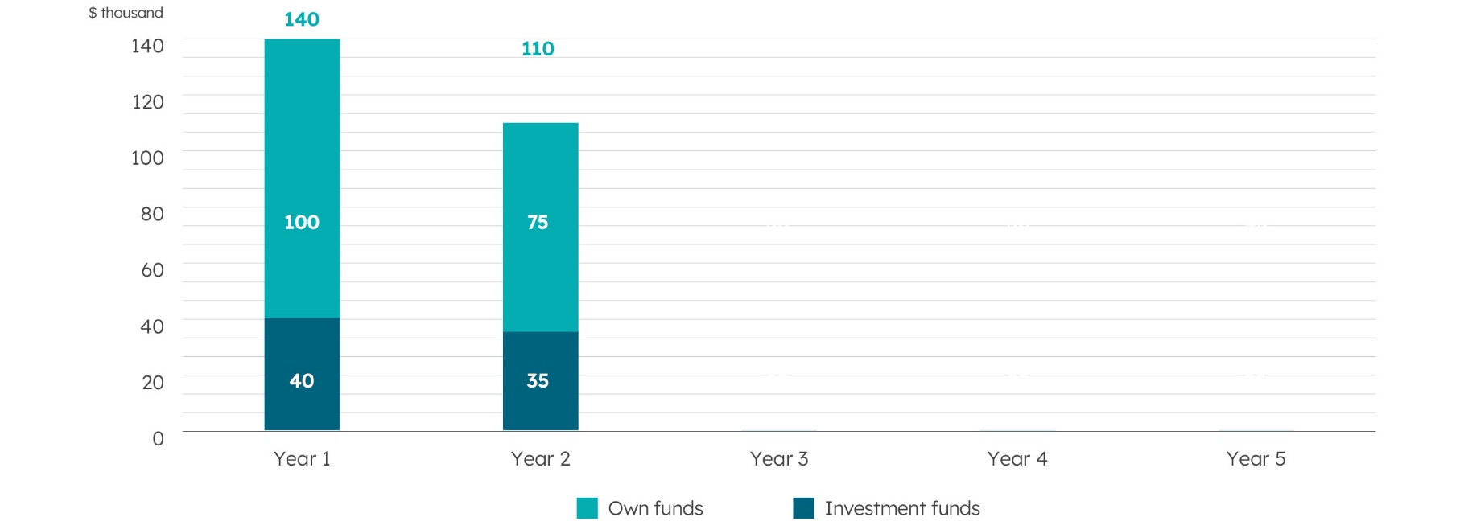
Sources of project financing
  - Financial performance
Investment performance ratios
Ratios | Benchmark Value | The company’s Indicator
ROI (Return on Investment), %
ROE (Return on Equity), %
ROA (Return on Assets), %
IRR (Internal Rate of Return), %
NPV (Net Present Value), thousand $
Payback Period

Investment Performance Ratios
Present the key investment ratios (ROI, ROE, ROA, IRR, NPV, and Payback Period) with their respective values. Briefly explain what each ratio measures and its significance for the project's profitability and efficiency. Highlight the implications of these ratios, indicating the attractiveness and risk level of the investment.

Start typing here...


Financial performance
Ratios | Benchmark Value | 1 year | 2 year | 3 year | 4 year | 5 year
Profitability ratios
Gross Margin, %
Net Profit Margin, %
EBITDA, thousand $
Net Profit, thousand $
Profitability ratios


Profitability ratios
List the key profitability ratios and their forecasted values. Explain the significance of each ratio and its anticipated improvement over the forecast period. Highlight the reasons behind the expected changes and what they indicate about the company's performance.

Start typing here...






Your address here
Email@.com
Brandname.com
Your address here

